Fishing gear 1: Spanish longline
The fishing gear is composed of the main line (ø 18mm) conformed of segments or “paños” 80m long. At the end of each “paño” a secondary line (or dropper line), ø 8mm and 16 m long, is attached, with a weight (8.5 kg) at its end. The hook line (ø 3 mm) extends between each secondary line (80m), carrying snoods every 2 m. Each snood is ø 1.2 mm and 1 m long, having a single hook, size 9, at its end. Intermediate weights are added every 40m. Whole sardines, thaw, are used as bait.
A line is composed in average by 200 “paños”, totalling 8,000 hooks per line. Two lines are set and haul per day.
Specifications for each component are provided below.
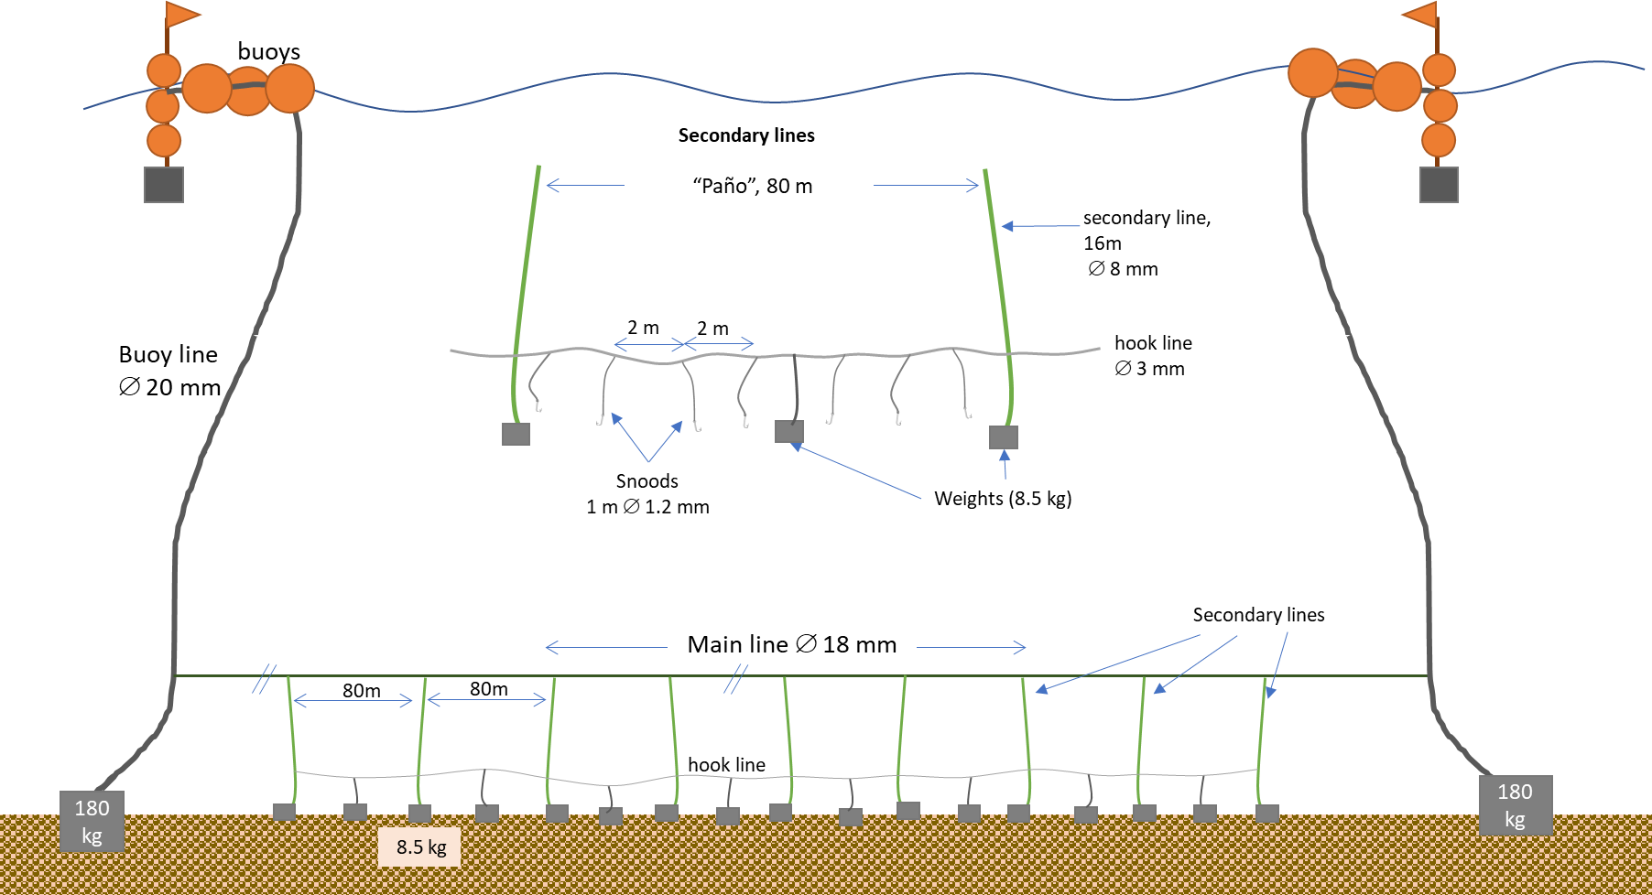
Diagram indicating the components of the fishing line.

Detail of material, diameter, length or weight of the main components of the fishing gear.
Component | Material | Diameter (mm) | Length / spacing (m) | Weight (kg)
Main Line | PE | 18 | 80 (segment)
Secondary line | PE | 8 | 16
Hook line | Monofilament | 3.0 | 40
Snood | Monofilament | 1.2 | 1.0
Weight @ secondary lines | stone blocks |  | 40m | 8.5
Anchorage (ends) | Stones |  |  | 6 x 30kg
Hooks are J-type, size 9.

