Appendix 4; Fishing gear plans San Aspiring as specified in CM 22-06; Annex 22-06/A Par 1.2.1

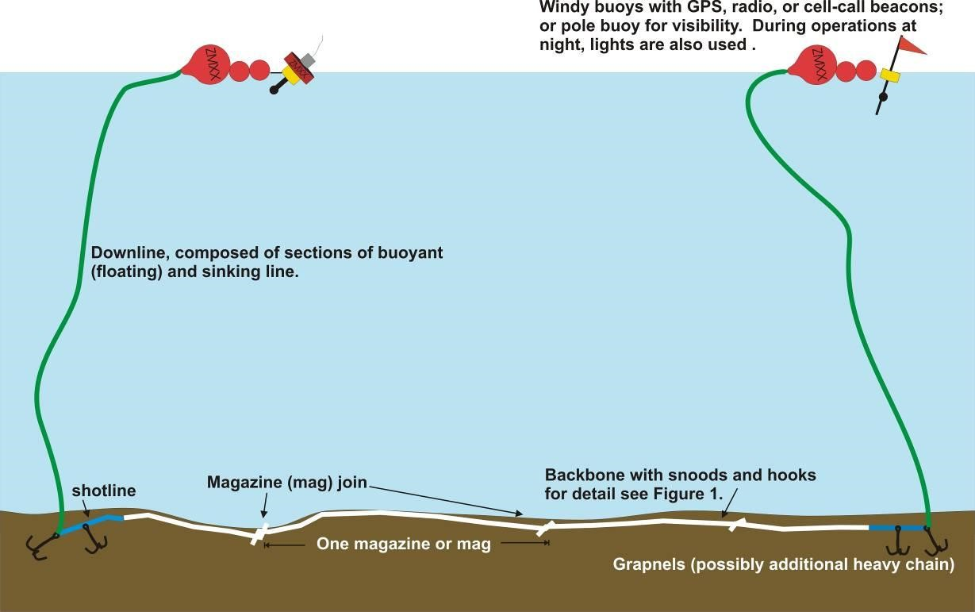

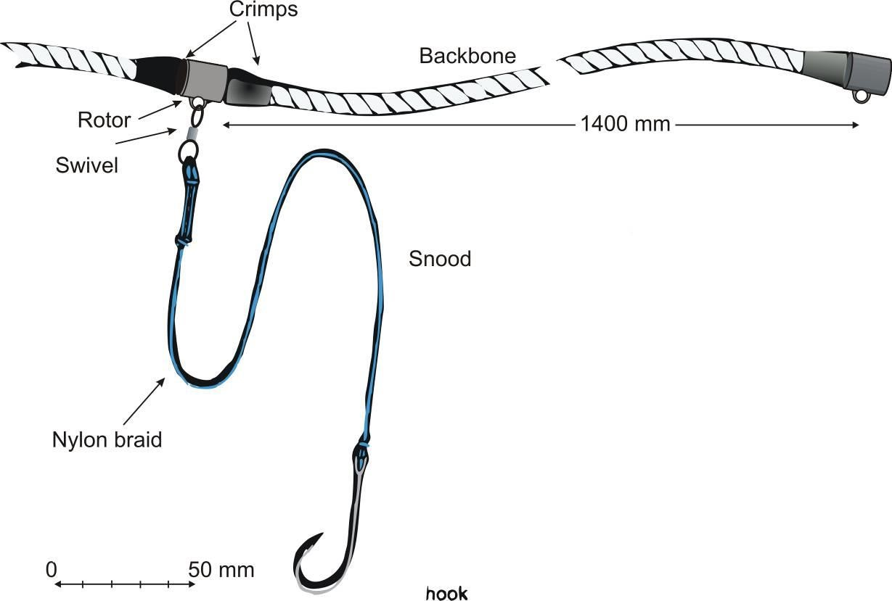

Table 4. Ranges of line lengths and hook numbers from San Aspiring records averaged over the past three completed fishing seasons in Subarea 88.1 and 88.2.

 | Minimum | Average | Maximum
Line length | 1,799 m | 10,947 m | 15,597 m
Number of hooks | 1,285 | 7,819 | 11,141

Table 5. Description of main gear items

Item | Description
Backbone | 12 mm lead-core internally weighted polypropylene/nylon line at 50g/m (Fiskevegn AS)
Grapnels | 40 or 50 kg - two or four used per line depending on sea, bottom, and tidal conditions
Weights | About 5 kg - rarely used, tied to the line occasionally when setting in loose sea ice or when turning while setting
Hook type | 15mm straight shank 15/O hooks
Chain | Lengths of heavy chain generally 20 or 40 kg used for additional weighting at the line ends.
Floats | Only surface floats, either inflatable or pressure floats depending on ice conditions
Snoods | 40-50cm blue Capron™ snoods spaced at 1400 mm

