Auto Longlining
The nominated Australian vessel will be targeting Antarctic toothfish (Dissostichus mawsoni) using a 40, 000 hook Mustad Autoline System including a Mustad 3000 Autobaiter baiting machine. The vessel is also fitted with an SP2000 Mustad Autoline hook separator, Autoline Combi haulers, and Mustad Line Controller systems (to reduce the chance of line breakage).

Figure 1: Auto Longline Fishing System

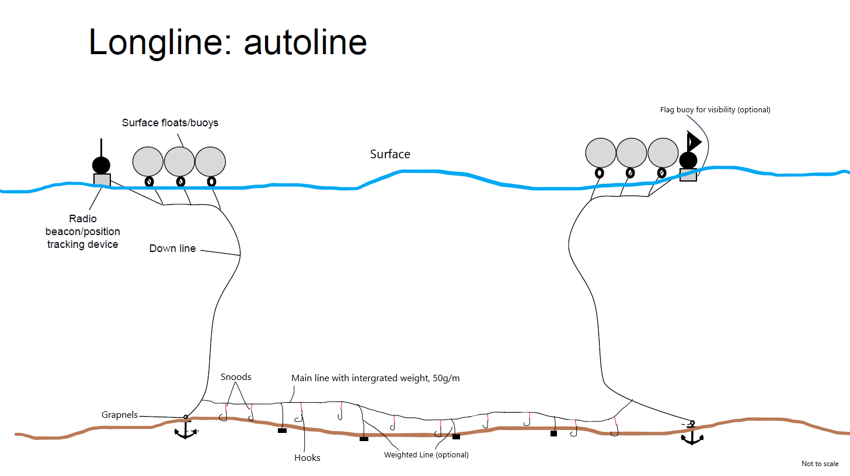

Figure 2: Hook type
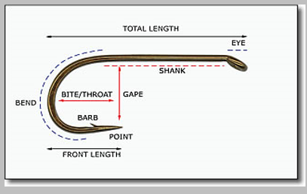

Table 1: Antarctic Discovery desciption of main gear items
Item |  | Descriptions
Main line |  | 12.0mm Integrated weighted line (IWL) at 50 grams per lead per meter of line
Downline |  | 12.0mm line
Grapnels |  | 2x80kg grapnels used per line.
Hooks | Type | Circle & J-hook hybrid, 2X extra-heavy and extra forged wire, Impregn. Twisted polyester, sewn loop
Hooks | Spacing | 1.4m apart
Hooks | Length (cm) | 8
Hooks | Shank Length (cm) | 6
Hooks | Gape (cm) | 1.8
Hooks | Throat (cm) | 3.2
Hooks | Front length (cm) | 3.5
Hooks | Spacing (m) | 1.4
Floats |  | Surface floats only
Snoods |  | Polyester snoods of 0.45m length

