Fishing gear 2: Trotline (with cachalotera)
The fishing gear is composed of the main line (ø 18mm) conformed of segments or “paños” 200m long, from which 13 to 21 secondary lines (branch lines) per segment are attached (every ~10 to 15m). Each secondary line (ø 8mm) has a branch line (16m in length), a cluster of 6 hooks (size 9), a “cachalotera” and a weight (6 kg). Whole sardines, thaw, are used as bait.
A line is composed in average by 900 secondary (dropper) lines, totalling 5,400 hooks per line. Up to three lines are set and haul per day.
Specifications for each component are provided below.

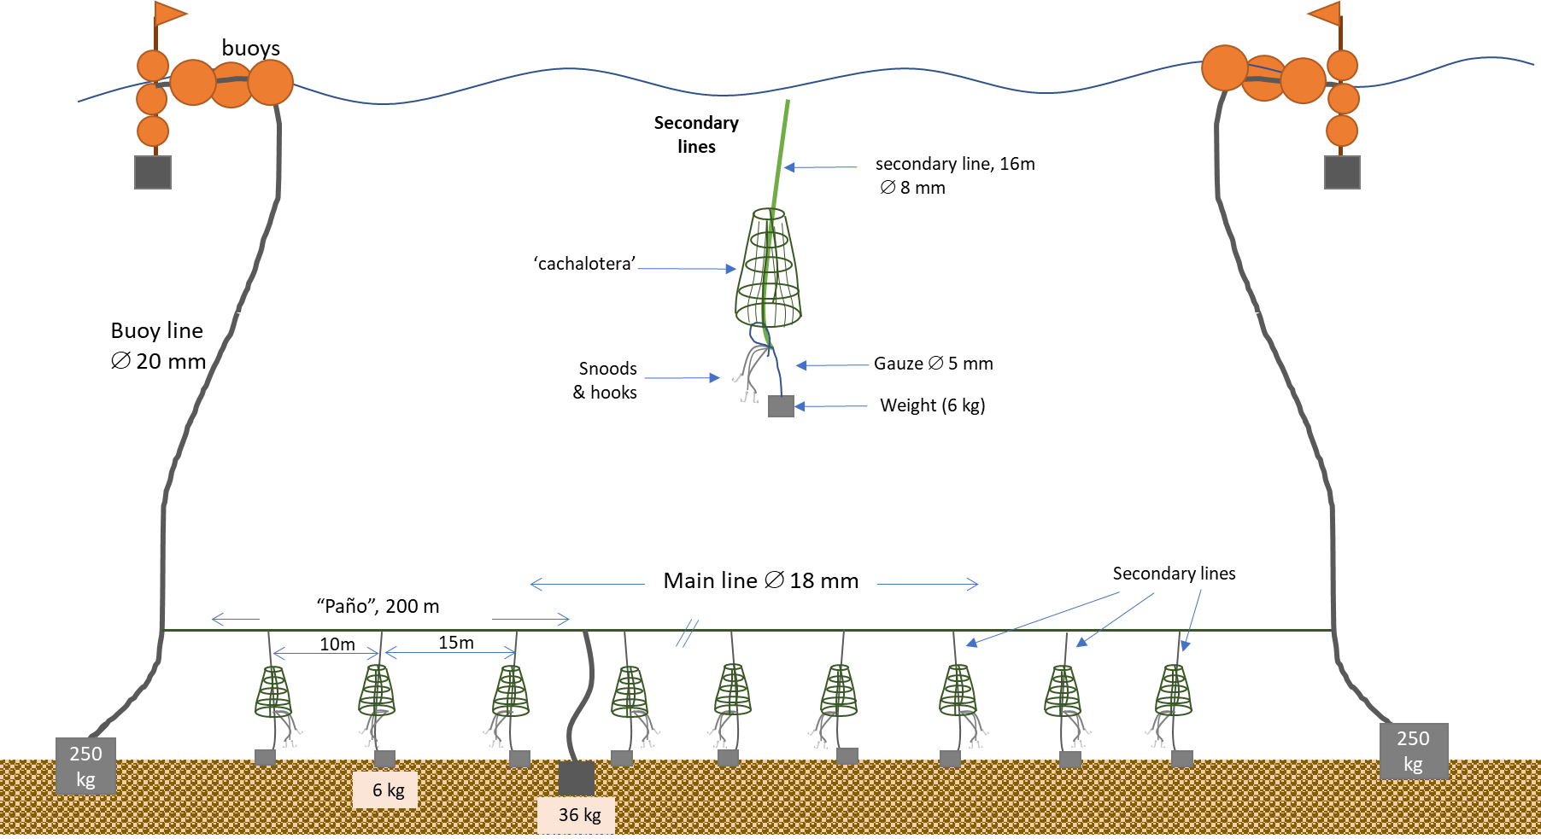
Diagram indicating the components of the fishing line.

Detail of material, diameter, length or weight of the main components of the fishing gear.
Component | Material | Diameter (mm) | Length/spacing (m) | Weight (kg)
Main Line | PE | 18 | 200 (segment)
Weight @ segments | stone blocks |  | 200 | 36kg
Secondary line | PE | 8 | 16
Snood | Monofilament | 1.2 | 1.0
Weight @ secondary lines | stone blocks |  | 10-15 | 6
Anchorage (ends) | Stones |  |  | 6-8 x 36kg
Hooks are J-type, size 9.
The ‘cachalotera’ is made of net (mesh size: 12x8 cm) and rope (∅ 8mm), with the following dimensions:
Total height (m) 1,85
Top ring diameter (cm) 14 - 16
Bottom ring diameter (cm) 60-70

