Gear diagram: Austral Odyssey
The nominated Australian vessel will target Antarctic toothfish (Dissostichus mawsoni) using a 60,000 hook Mustad Autoline E-Line system. This includes a Mustad E-Line BM-6000 Superbaiter baiting machine, a Mustad Autoline E-Line HS-2020 hook separator, and Mustad Autoline E-Line 4000 E-Line Hauling Station.
Fishing gear will be demersal autoline (integrated weight) gear, consisting of a 12mm IWL backbone with 15/0 hooks on a 40cm snood, at a 1.4m spacing (Figures 1 and 2).
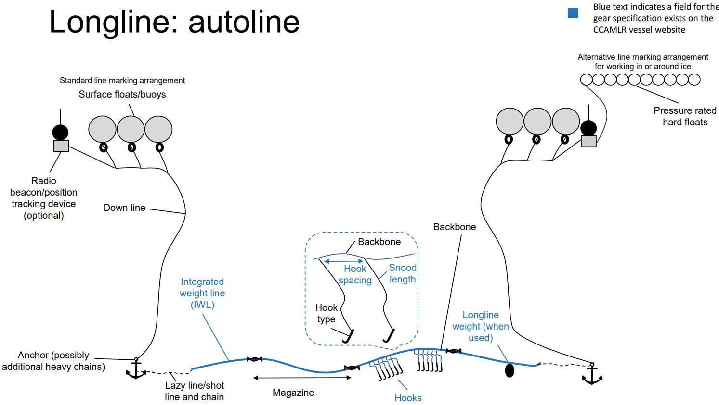
Figure 1: Diagram of a typical demersal Autoline setup, as will be used on the Austral Odyssey in the Ross Sea and Amundsen Sea fisheries.

Table 1: Description of main Austral Odyssey gear items
Hooks |  | Descriptions
Main Line |  | 12mm IWL 50g/m
Downline |  | 14.0mm tarred line
Grapnels |  | 4x60kg grapnels used per line.
Hooks | Type | 15/0 - A.S Fiskevegn, Eagle hook
Hooks | Spacing | 1.4 m apart
Hooks | Length (cm) | 9
Hooks | Shank length (cm) | 5.5
Hooks | Gape (cm) | 2
Hooks | Throat (cm) | 4
Hooks | Front length (cm) | 3.5
Floats |  | 280mm Pressure Floats (22-24 per end of line)
Snoods |  | 30-40cm (after hanging)– Polyester, Polyethylene coating.

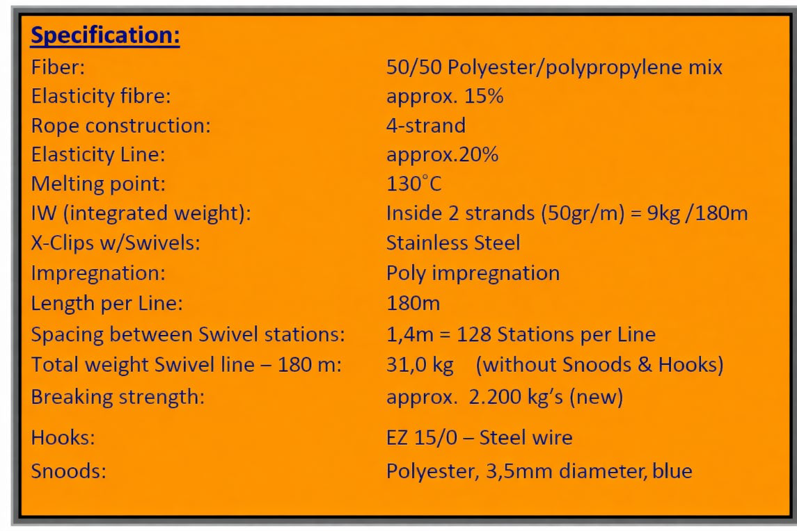
Figure 2: Specifications of Austral Odyssey’s autoline – Fiskevegn’s 12mm IW-X line.

