Fishing gear Diagram details

Fishing gear configuration
Figure 1. Fishing gear diagram & detail.
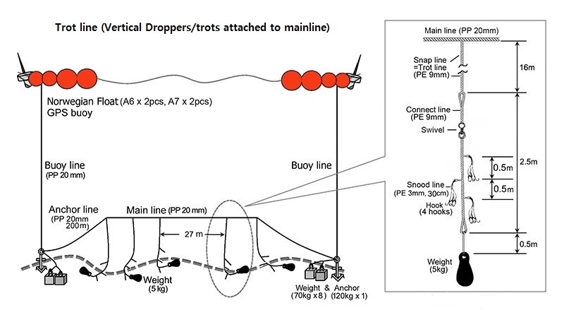

Figure 2. The parts of connect line

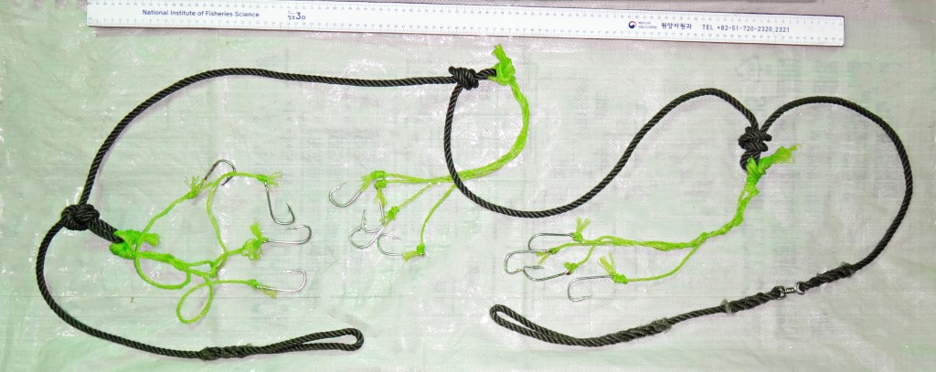

Figure 3. Detail of Hook
Part of Hook | Specifications | 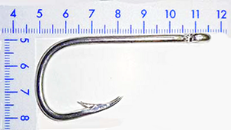
Front Length | 32mm
Total Length | 65mm
Gape | 22mm
Diameter | Ø3.2mm
N.Weight | 7.5g

