Net configuration
Net 1 diagram(s): SEJONG
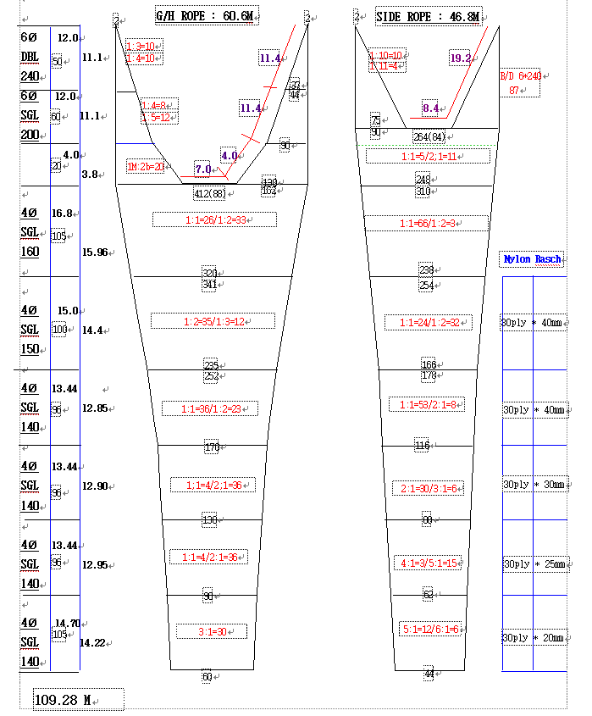
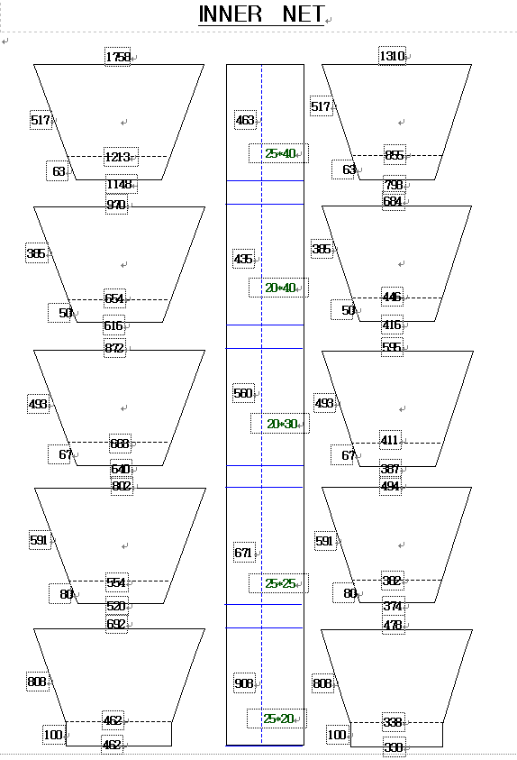

For each net used, or any change in net configuration, refer to the relevant net diagram in the CCAMLR fishing
gear library if available (www.ccamlr.org/node/74407), or submit a detailed diagram and description to the
forthcoming meeting of WG-EMM. Net diagrams must include:
1. Length and width of each trawl panel (in sufficient detail to allow calculation of the angle of each panel
with respect to water flow.)
2. Mesh size (inside measurement of stretched mesh based on the procedure in Conservation Measure 22-01),
shape (e.g. diamond shape) and material (e.g. polypropylene).
3. Mesh construction (e.g. knotted, fused).
4. Details of streamers used inside the trawl (design, location on panels, indicate ‘nil’ if streamers are not
in use); streamers prevent krill fouling the mesh or escaping.

Net 2 diagram(s): SEJONG
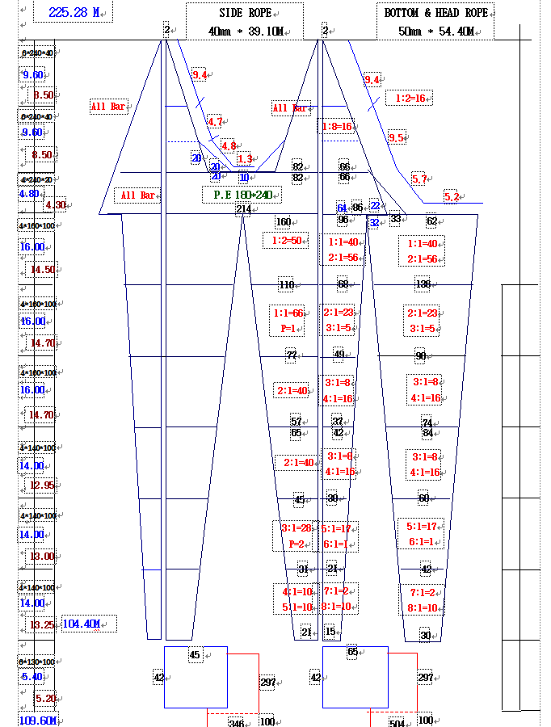

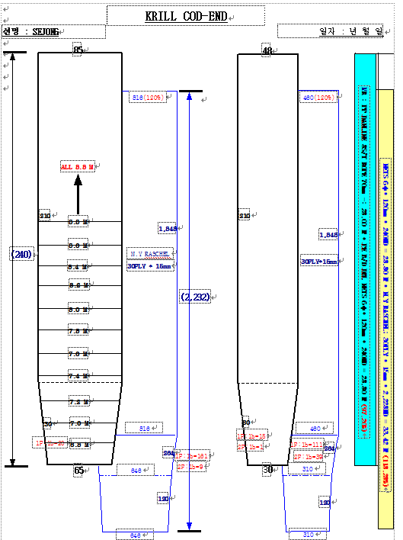

For each net used, or any change in net configuration, refer to the relevant net diagram in the CCAMLR fishing
gear library if available (www.ccamlr.org/node/74407), or submit a detailed diagram and description to the
forthcoming meeting of WG-EMM. Net diagrams must include:
1. Length and width of each trawl panel (in sufficient detail to allow calculation of the angle of each panel
with respect to water flow.)
2. Mesh size (inside measurement of stretched mesh based on the procedure in Conservation Measure 22-01),
shape (e.g. diamond shape) and material (e.g. polypropylene).
3. Mesh construction (e.g. knotted, fused).
4. Details of streamers used inside the trawl (design, location on panels, indicate ‘nil’ if streamers are not
in use); streamers prevent krill fouling the mesh or escaping.

