48.4 Assessment Summary
Tim Earl

Abstract
The following document was submitted to the Stock Assessment Review process to outline the source of current model data and parameters, and to summarise the development of the model. Section 1 summarises the development of the model, this is documented in more detail in Section 15, with a comprehensive reference list of papers related to the development of the model. Sections 2-13 describe the input files used in the most recent (2017) assessment, indicating the source of externally estimated parameters, and the data used in fitting the model. Section 14 outlines the data weighting approach used in fitting the model to multiple sources of data.

48.4 Assessment Summary
Tim Earl

Development history
Year | Changes from previous assessment
2013 | First assessment of TOP in 484
2014 | Comparison of maturity ogives
2015 | Updated maturity ogives. Changes to mortality post tagging
2017 | Number of years of recaptures post-tagging reduced from 6 to 4

In the associated bundle:
- Input files after Francis weighting
- All papers referred to in this document (FSA-17-52 is the most recent assessment) These are referenced in full in Table 1.
Current assessment:
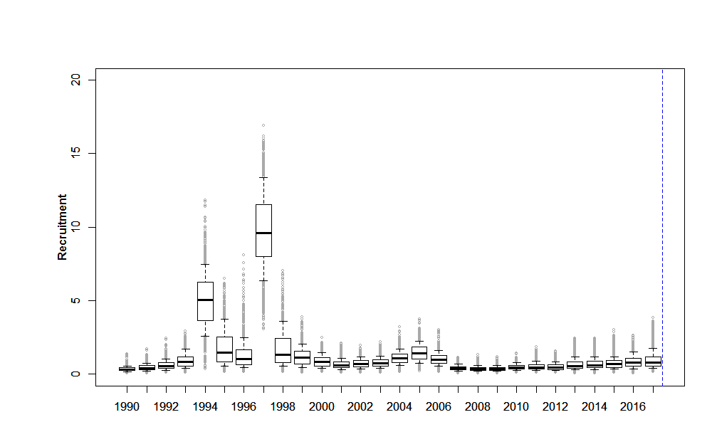
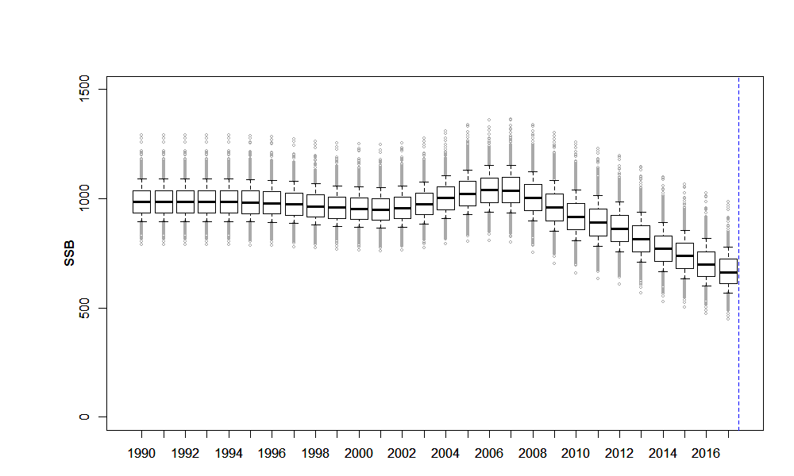
Figure 1: Recruitment (top), and SSB (bottom) estimates for the 2017 assessment, base on MCMC uncertainty estimates

Model setup

Values
Age range: 1-50+
Year range 1990-present
Single area, single stock with no separate sex/maturity partition
Annual cycle:
- t=0.25 years
- Spawning_time, fishery t=0.3333333 years (partial mortality 0.5) years spawning_ps
- Recruitment t=0.4166667 years
- Aging t=0 years
Apart from the year range, these are consistent with 483 to allow combination into a single model if appropriate in the future.

Model representation
Population.csl
@size_based False
@min_age 1
@max_age 50
@plus_group True
@sex_partition False
@mature_partition False
@n_areas 1
@n_stocks 1
@n_tags 12
@tag_names 2005Tags ... 2016Tags

@initial 1990
@current 2017
@final 2052

@annual_cycle
time_steps 4
recruitment_time 1
spawning_time 2
spawning_part_mort 0.5
spawning_ps 1.0
aging_time 4
M_props 0.4166667 0.3333333 0.25 0.0
growth_props 0.4166667 0.75 1.0 0.0
baranov False
fishery_names FSSI
fishery_times 2

@y_enter 1
@n_quant 15

Notes
Annual cycle chosen to be consistent with 48.3

References

Optimiser settings

Model representation
Estimation.csl
@estimator Bayes
@max_iters 1000
@max_evals 4000
@grad_tol 0.002

@MCMC
start 0
length 1300000
keep 3000
adaptive_stepsize True
adapt_at 100000 200000
burn_in 100
proposal_t True
df 4

@profile
parameter initialization.B0
n 10
l 600
u 3000

@q_method nuisance

@ageing_error
type normal
c 0.1

Notes
Profile range updated in 2018

Initial biomass

Values
B0 initialised at 2,000 tonnes
Uniform-log prior on 500 tonnes to 5,000 tonnes

Processing

Scripts

Assumptions

Model representation
Population.csl
@initialization
B0 2000
Estimation.csl
@estimate
parameter initialization.B0
lower_bound 500
upper_bound 5000
prior uniform-log
phase 1

Recruitment
Beverton Holt recruitment form, with initial value of steepness set to 0.75.

Source data/Values
Free estimates 1985-(current-7)
Year_range 1992-(current-6)
@randomisation_method lognormal-empirical
Priors bounded on [0.001,20], lognormally distributed with mu=1, cv=0.8, except first year and last 7 which are fixed to 1.

Model representation
Population.csl
@recruitment
YCS_years 1989 ... 2016
YCS 1 ...1
SR BH
steepness 0.75
sigma_r 1.0
first_free 1989
last_free 2009

@first_random_year 2010

@randomisation_method lognormal

@standardise_YCS True
Estimation.csl
@estimate
parameter recruitment.YCS
#YCS_years 1989 ... 2016
lower_bound 0.001 ... 0.001
upper_bound 20 ... 20
prior lognormal
mu 1 ... 1
cv 0.658 ... 0.658
phase 1

Maturity ogive
Fixed ogive at age

Source data/Values
Taken from 48.3, note that there is no evidence of spawning in 48.4, an alternative hypothesis to a unit stock, is that fish return to 48.3 to spawn.

Model representation
Population.csl
@maturity_props
all allvalues_bounded 1 23 0 0 0 0 0 0.06 0.14 0.22 0.3 0.38 0.46 0.54 0.62 0.658 0.7 0.742 0.784 0.826 0.868 0.91 0.952 0.994 1

Natural mortality
Fixed value for all ages

Source data/Values
0.13

Model representation
Population.csl
@natural_mortality
all 0.13

References
WG-FSA-05/18

Growth
Growth data is estimated within the model. Because of lack of data on small fish, t0 is assumed zero.

Source data/Values

Model representation
Population.csl
@size_at_age_type von_Bert
@size_at_age_dist normal

@size_at_age
k 0.092
t0 0.00
Linf 153.0
cv 0.08

@size_weight
a 4.150e-09
b 3.194
verify_size_weight 150 30 50
Estimation.csl
@estimate
parameter size_at_age.k
lower_bound 0.03 #changed from 0.05
upper_bound 0.20 # changed from 0.15 - VL
prior uniform
phase 1

@estimate
parameter size_at_age.Linf
lower_bound 110
upper_bound 250
prior uniform
phase 1
MCMC_fixed True

@age_size sizedata2011
...
@age_size sizedata2017
year 2017
step 2
sample random
ogive SelSSI
ages <Ages of aged fish>
sizes <Lengths of aged fish>

Notes
Growth estimated externally in 48.3, internally in 48.4

Tagging release data
Tagging data is available from 2003 release cohort onwards. Release mortality is estimated externally using a length dependent relationship:
Length class (cm) | 30, 40 | 50 | 60 | 70 | 80 | 90 | 100+
Survival | 0 | 0.96 | 0.95 | 0.95 | 0.94 | 0.83 | 0.80
Within the model, no further post-release tagging occurs.
All releases since 2003 are included where the fish length is in the range [30,200) cm, the release area is 48.4 and the release species is recorded as “TOP”.

Source data/Values
Tag shedding rate 0.006377 based on linear approximation over four years to the observed double tag loss rate.
There is a 0.75 year no growth period – WG-FSA-07/29

Model representation
Population.csl
@tag_shedding_rate 0.0064 ... 0.0064
@tag_loss_props 0.4166667 0.3333333 0.25 0.0

@tag_growth_loss 2005Tags
nogrowth_period 0.75
...
@tag_growth_loss 2016Tags
nogrowth_period 0.75

@tag 2005Tags
...
@tag 2016Tags
tag_name 2016Tags
release_type deterministic
sex both
year 2016
step 2
mature_only False
number 159
plus_group False
class_mins 20 30 40 50 60 70 80 90 100 110 120 130 140 150 160 170 180
props_all 0.000 0.000 0.000 0.000 0.006 0.013 0.019 0.031 0.157 0.094 0.107 0.245 0.176 0.101 0.044 0.006
mortality 0.1
ogive SelSSI

Notes
Instant tag mortality is estimated externally, based on a length-dependent relationship, and so no further tag mortality is applied in the model.

References
Tag mortality at length described in WG-FSA-07/29
Effect of double tagging: WG-SAM-11/16 and WG-SAM-11/12 leading to tag loss rate estimate
WG-SAM-09/13: Adding catch at age and survey data to the 48.3 toothfish CASAL assessment.

Tag recaptures

Model representation
Estimation.csl
@tag_recapture 2005Tags
...
@tag_recapture 2016Tags
tag_name 2016Tags
sample size
detection_probability 1
years 2017
step 2
proportion_mortality 1.0
plus_group True
class_mins 30 40 50 60 70 80 90 100 110 120 130 140 150 160 170 180 190 200
recaptured_2017 0 0 0 0 0 0 0 0 1 2 3 0 0 0 0 0 0 0
scanned_2017 0.000 0.000 0.000 4.256 4.711 20.086 50.288 111.235 91.742 182.692 285.505 253.355 119.596 42.795 12.119 2.441 0.000 0.000
do_bootstrap True
r 1e-11
dispersion 2.070249

@fish_tagged_penalty
label 2005TagPenalty
tagging_episode 2005Tags
multiplier 1
...
@fish_tagged_penalty
label 2016TagPenalty
tagging_episode 2016Tags
multiplier 1

Notes
For each tagging cohort, the four following years recaptures are included. Scanned numbers based on raised numbers at length. Prior to 2017, this was six years (WG-SAM-17/35)

Catches
Future catches (for 35 years based on the CCAMLR harvest control rule)

Model representation
Population.csl
@fishery FSSI
years 2005 ... 2017
catches 26.88 18.73 54.04 97.63 74.4 57.46 38.65 55.41 72.32 43.8 41.696 41.601 27.912 #Check 2017 catch
U_max 0.999
selectivity SelSSI
future_years 2018 2019 2020 2021 2022 2023 2024 2025 2026 2027 2028 2029 2030 2031 2032 2033 2034 2035 2036 2037 2038 2039 2040 2041 2042 2043 2044 2045 2046 2047 2048 2049 2050 2051 2052
future_catches <Constant value to achieve CCAMLR objectives>

Estimation.csl
@catch_limit_penalty
label catch_limit
log_scale False
fishery FSSI
multiplier 100

Catch composition
The observed length distribution is raised to an age distribution using a year-specific age length relationship.

Model representation
Population.csl
@selectivity_names SelSSI

@selectivity SelSSI
all logistic 8 4
Estimation.csl
@catch_at FSSICatch
years 2011 2012 2013 2014 2015 2016 2017
fishery FSSI
at_size False
sexed False
sum_to_one True
plus_group False
min_class 1
max_class 36
2011 <proportions at age>
...
2017

dist multinomial
N_2011 24.01
N_2012 23.35
N_2013 32.24
N_2014 26.91
N_2015 26.62
N_2016 127.84
N_2017 20
r 1e-11

@estimate
parameter selectivity[SelSSI].all
#lower_bound 1 0.05 1
#upper_bound 50 50 50
lower_bound 1 1
upper_bound 50 50
prior uniform
phase 1

Notes

References

Model Output

Model representation
Output.csl
@print
# estimation section stuff
parameters false
fits_every_eval false
objective_every_eval false
parameters_every_eval false
parameter_vector_every_eval false
fits true
resids true
pearson_resids true
normalised_resids false
estimation_section false
# population section stuff
requests true
initial_state false
state_annually false
state_every_step false
final_state true
results false
#output section stuff
yields true
unused_parameters true
covariance True

@quantities
all_free_parameters true
fishing_pressures true
nuisance_qs true
true_YCS true
B0 true
R0 true
SSBs true
YCS true
actual_catches false
ogive_parameters selectivity[SelSSI].all
fits true
normalised_resids false # set to true later
pearson_resids false
tagged_age_distribution true

@abundance vulnerable
biomass true
mature_only false
step 2
proportion_mortality 0.5
ogive SelSSI
years 2005 ... 2017

@numbers_at AgeStructure
step 2
proportion_mortality 0.5
years 2010 ... 2017

Data weighting
The data weighting is an iterative process. Initially an arbitrary effective sample size is assigned to the age composition in the year being added. The model is run, and the sample size recalculated based on the cv estimated for the age composition in this year. This process is repeated until the sample size converges (typically 3 or 4 iterations).

Papers used in the development of the assessment
Table 1: Papers relevant to the assessment of Toothfish in 48.4
Meeting | Paper summary
FSA-17 | WG-FSA-17/46 Preliminary results from the first year of a three-year survey into the connectivity of toothfish species in Subareas 48.2 and 48.4. K. Olsson, M. Belchier and M. Söffker  Very little catch of Patagonian toothfish so far  WG-FSA-17/52 Assessment of Patagonian toothfish (D. eleginoides) in Subarea 48.4. T. Earl  Update of assessment. Tagging truncated to four years following releasen season, rather than six used previously (following paper and discussion at SAM).  WG-FSA-17  3.20 Recommends to only use complete seasons of data that have been quality checked by the CCAMLR secretariat in future.  3.21 Recommends fitting survey as biomass and proportions in composition (not applicable)  3.28 Investigate temporal effects in fits to the tagging data  3.29 Further review of stock hypothesis to reflect links with 48.3
SAM-17 | 17/35 Sensitivities in the assessment of the Patagonian toothfish (D. eleginoides) in Subareas 48.3 and 48.4 to truncation of tagging data. T. Earl  Looking at the effect of including different numbers of years post release in the assessment. There is some outstanding bias in the tag recaptures not explained by the double-tagging effect.  WG-SAM-17  2.12 Recommendation to re-estimate the tag loss and instantaneous mortality using the most up to date data. Reduce years of tagging to four to reduce bias from double-tagging.
FSA-16 | NA
SAM-16 | NA
FSA-15 | WG-FSA-15/28 An integrated stock assessment of Patagonian toothfish (Dissostichus eleginoides) in CCAMLR Subarea 48.4  M. Soeffker, V. Laptikhovsky, T. Earl and C. Darby (United Kingdom)  Update of assessment  Updated maturity ogive and change to growth retardation period (0.5 changed to 0.75)  WG-FSA-15  4.15 Fixed recruitment from 2008-2015 investigated and used for catch advice, made little difference  4.17 WG recommends continuing with separate 48.3/48.4 assessments  4.18 Recommendations to reconsider recruitment used in projections  4.19 Only use 4 years recaptures in each tag cohort.  4.117(i)-(vii) Areas to develop stock assessments
SAM-15 | WG-SAM-15/30 A potential link between the D. eleginoides stocks of Statistical Subareas 48.3 and 48.4. M. Soeffker, M. Belchier and V. Laptikhovsky (United Kingdom)  Tags between 48.4 and 48.3 (mostly males moving to SG and females to SR) Lack of older and younger fish in 48.4 and different growth curves.  2.34-2.37, 2.42 Diagnostic documents  2.40 Document changes in a stepwise fashion
FSA-14 | WG-FSA-14/29 Rev. 1 A preliminary CASAL population assessment of Patagonian toothfish in CCAMLR Subarea 48.4 based on data for the 2009–2014 fishing seasons. V. Laptikhovsky, R. Scott, M. Söffker and C. Darby (United Kingdom)  Update of assessment  Comparison of maturity ogives  4.4 Spread sampling of otoliths across the length distribution
SAM-14 | WG-SAM-14  2.29 CASAL version 2.30-2012-03-21 rev 4648 be considered the current approved CCAMLR version
FSA-13 | WG-FSA-13/31 Preliminary assessment of Patagonian toothfish in Subarea 48.4. R. Scott and V. Laptikohvsky (United Kingdom)  First TOP specific assessment (previously northern combined TOP and TOA). Maturity data based on limited samples from 48.4. 2009 catch composition rejected as based on few samples and introduces convergence issues as conflict with 2012 data – the more recent data was thought to be more reliable. Francis data weighting introduced  WG-FSA-13  4.28 exclude 2009 length composition data  4.29 Data weighting by Francis method not adopted due to reducing the uncertainty in MCMC estimates unexpectedly  4.93 MPD B0 estimates are validated by the secretariat rerunning assessment.  4.96 Differences in B0 from different versions of CASAL not explained
SAM-13 | WG-SAM-13/24 A revised assessment of Patagonian toothfish in Subarea 48.4. R. Scott (United Kingdom)  Change to maturity ogive, change in selectivity pattern
FSA-12 | WG-FSA-12/36 Population assessment of Patagonian toothfish in Subarea 48.4. R. Scott (United Kingdom)  Assessment for Northern 48.4 combined toothfish  5.32 Assess 48.4 toothfish by species rather than area
SAM-12
Before 2012 the assessment covered a considerably different stock, and so subsequent papers only refer to general stock assessment methodology rather than the specific assessments in 48.4
FSA-11
SAM-11 | WG-SAM-11/12 Models of tag shedding for double tagging as a function of time at liberty and approximate solutions for the single tagging model in CASAL. S.G. Candy (Australia)  WG-SAM-11/18 Estimates of the tag loss rates for single and double tagged toothfish (Dissostichus mawsoni) fishery in the Ross Sea. A. Dunn, M.H. Smith (New Zealand), D.J. Agnew (UK) and S. Mormede (New Zealand)  Discussion of double tagging effect, and its application to the Ross Sea fishery
FSA-10 | WG-FSA-10/P05 The Patagonian toothfish: biology, ecology and fishery. M.A. Collins, P. Brickle, J. Brown and M. Belchier  Everything about Toothfish
SAM-10 | WG-SAM-10/11 Rev. 1 Estimation of natural mortality using catch-at-age and aged mark-recapture data: a simulation study comparing estimation for a model based on the Baranov equations versus a new mortality equation. S.G. Candy (Australia)  Simulation testing estimation of M  WG-SAM-10  Discussion of estimates of M
FSA-09 | WG-FSA-09/22 Rev. 1 COMPARISON OF THE PRECISION OF DIRECT VERSUS AGE LENGTH KEY METHODS OF ESTIMATING CATCH-AT-AGE PROPORTIONS  S.G. Candy (Australia)  Sampling ages based on length binned samples rather than unbinned samples
SAM-09 | NA
FSA-08 | NA
SAM-08 | NA
FSA-07 | WG-FSA-07  Report: Investigate issues including use of catch-at-age and tag recapture at length bias in 48.3 assessment.
SAM-07 | WG-SAM-07/13 An assessment strategy evaluation framework for testing the application of a CASAL based management system to the HIMI fishery  I.R. Ball and S.G. Candy (Australia)  WG-SAM-07/7 Comparison of estimators of effective sample size for catch-at-age and catch-at-length data using simulated data from the Dirichlet-multinomial Distribution  S.G. Candy (Australia)  Method of calculating sample size
FSA-06 | NA
FSA-SAM-06 | NA
FSA-05 | WG-FSA-05/18 Parameters for the assessment of toothfish in Subarea 48.3. D.J. Agnew, G.P. Kirkwood, A. Payne, J. Pearce and J. Clarke (United Kingdom)  Beverton-Holt invariants presented  WG-FSA-05  4.18 Discussion about recruitment uncertainty in projections

Throughout this document the data included is that which was available at the end of the 2016/17 fishing season, i.e. the extent of the data is the same as for the assessment presented at WG-FSA-17.

