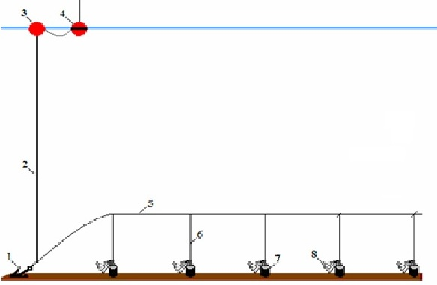

Figure 1. Scheme of the bottom longline (trot-line) aboard of SIMEIZ: 1 - anchor; 2 - buoy rope;
3 - buoy; 4 - radio buoy; 5 - mainline; 6 – dropline; 7 - concrete cylindrical weights; 8 - bunch of
5 hooking snoods.

