Marine mammal exclusion device
Device diagram(s): SEJONG
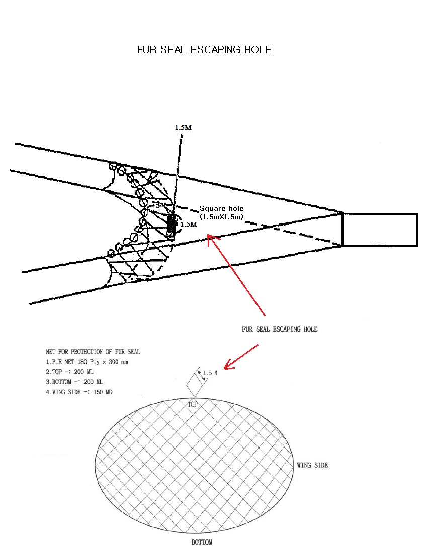
NET FOR PROTECTION OF FUR SEAL
- P.E NET 180PLY X 300mm
- TOP : 220 ML
- BOTTOM : 220 ML
- WING SIDE : 166 MD
For each type of device used, or any change in device configuration, refer to the relevant diagram in the
CCAMLR fishing gear library if available (www.ccamlr.org/node/74407), or submit a detailed diagram and
description to the forthcoming meeting of WG-EMM.

