- Calibration/standardisation of sampling gear

Trotline would be used for Dissostichus spp. throughout whole activities in the CCAMLR Convention Area. The system consists of main line (polypropylene, ø20 mm) and a series of several hundred trotlines (p/p ø10 mm, 16 mm length), joined consequently to the main line. The total length of the main line varied from 6,000 to 25,000m. Trotline has 3 clusters of hooks; each cluster has 4-5 hooks (size 30x75 mm, steel, made in South Korea) and two 5 kg steel weights at the end. The distance between the clusters is 0.5m - 1.2 m.)
The system of trotline would be equipped with radio buoy (PR-30A), red colored and marked by call sign inflatable buoys and anchor (100-120 kg) with the additional three weights; 70kg in total. The “setting” of the trotline is carried out from the stern, hauling – from the starboard side. To sum up;
Trot line: About 3,000 – 20,000ea hooks are deployed on each set (Figure 1)
- Lazy line (from anchor to before mainline) is 200-250m. Branch line (connect line + snap line) is connected to main line. At the bottom end of this branch line, 2 weights are connected and weight of them are 5kgs each (total 10 kgs).
- The branch lines are connected to main line successively at interval of 22~35m.
- To each branch line, there are 3-5 clusters and each of them consists of 4-5 hooks (total 12-25 hooks at branch line)
- Attaching a small float on connect line makes fishing gear move vertically. Small float’s buoyancy prevents fishing hooks and sinkers from contacting with the seafloor during fishing.
- Therefore, we believe that the trot-line system can cause very low impact on VMEs and seabirds.
- It takes about 30 minutes to complete the setting and 2.5 hours for hauling for depth 800m- 1,500m
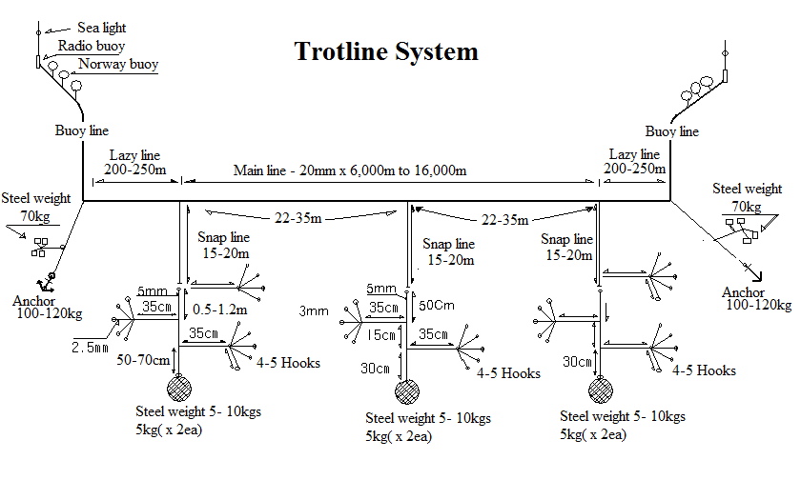
Figure 1. Fishing gears; trot line (upper side) used in the Convention Area.

