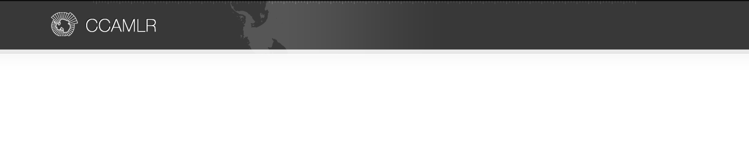ANNEX 21-03/A

**NOTIFICATION OF INTENT TO PARTICIPATE IN A FISHERY**

**FOR *EUPHAUSIA SUPERBA***

**General information**

Member: Republic of Korea

Fishing season: 2021/22 season

Name of vessel: SEJONG

Expected level of catch (tonnes of green weight): 20,000

Vessel’s daily processing capacity (tonnes of green weight) 240

**Intended fishing subareas and divisions**

*This conservation measure applies to notifications of intentions to fish for krill in Subareas 48.1, 48.2, 48.3*

*and 48.4 and Divisions 58.4.1 and 58.4.2. Intentions to fish for krill in other subareas and divisions must be*

*notified under Conservation Measure 21-02.*

|  |  |
| --- | --- |
| Subarea/division | Tick the appropriate boxes |
| 48.1 | V |
| 48.2 | V |
| 48.3 | V |
| 48.4 |  |
| 58.4.1 |  |
| 58.4.2 |  |

Fishing technique : Tick the appropriate boxes

V Conventional trawl

□ Continuous fishing system

□ Pumping to clear codend

□ Other method: Please specify ___________________________

**Product types and methods for direct estimation of green weight of krill caught**

|  |  |
| --- | --- |
| Product type | Method for direct estimation of green weight of krill caught,  where relevant (refer to Annex 21-03/B)1 |
| Whole frozen | Holding tank volume |
| Boiled | Holding tank volume |
| Meal | Holding tank volume |
| Oil |  |
| Peeled | Holding tank volume |

1 If the method is not listed in Annex 21-03/B, then please describe in detail ______________

|  |  |  |  |
| --- | --- | --- | --- |
| Net measurements | Net 1 | Net 2 | Net 3 |
| Net-mouth opening height (m) | 25.00 | 25.00 | 34 |
| Net-mouth opening width (m) | 30.00 | 27.60 | 35 |
| Total net length (m) including codend, measured along the centreline of the net | 137.28 | 137.50 | 155.07 |
| Codend-mouth opening height (m) | 2.88 | 2.88 | 2.88 |
| Codend-mouth opening width (m) | 4.56 | 4.56 | 4.56 |
| Codend length (m) | 28.00 | 28.00 | 28.00 |
| Codend mesh size (mm: stretched mesh) | 120  (Inner 15) | 120  (Inner 15) | 100  (Inner 15) |

**Net configuration**

Net 1 diagram(s): SEJONG

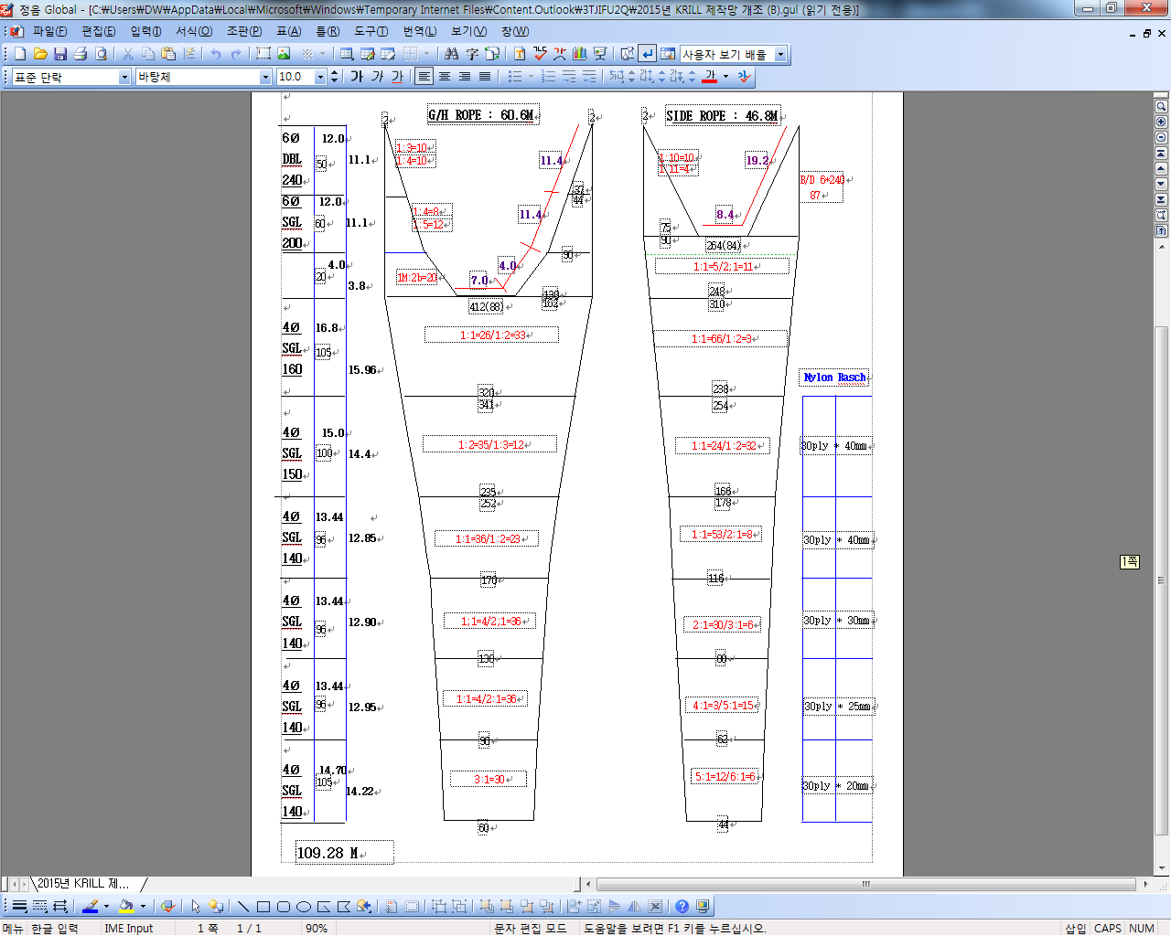

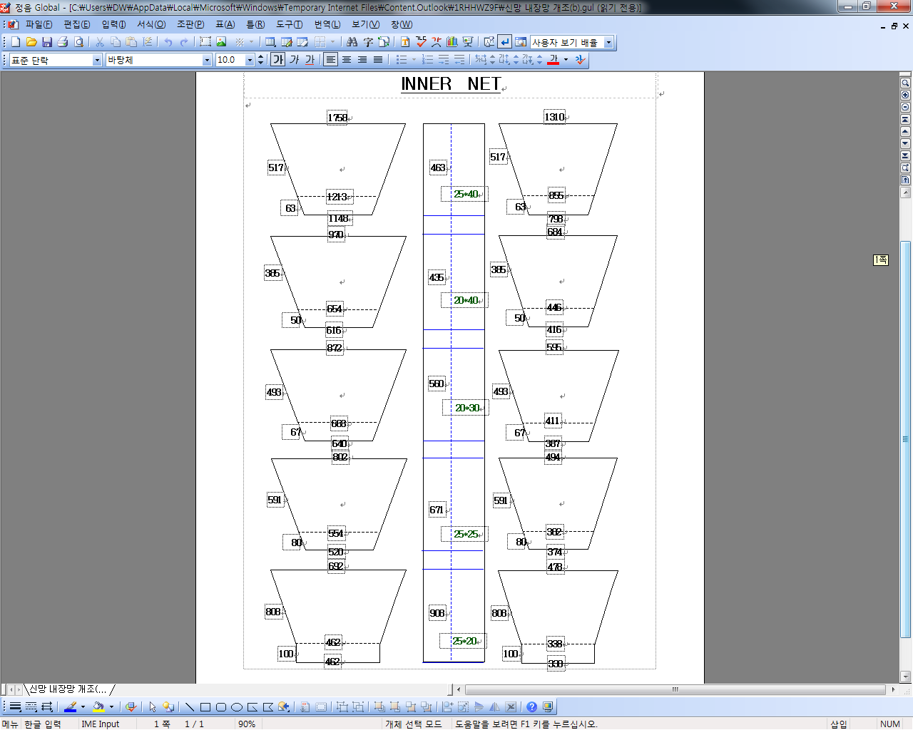

*For each net used, or any change in net configuration, refer to the relevant net diagram in the CCAMLR fishing*

*gear library if available (www.ccamlr.org/node/74407), or submit a detailed diagram and description to the*

*forthcoming meeting of WG-EMM. Net diagrams must include:*

*1. Length and width of each trawl panel (in sufficient detail to allow calculation of the angle of each panel*

*with respect to water flow.)*

*2. Mesh size (inside measurement of stretched mesh based on the procedure in Conservation Measure 22-01),*

*shape (e.g. diamond shape) and material (e.g. polypropylene).*

*3. Mesh construction (e.g. knotted, fused).*

*4. Details of streamers used inside the trawl (design, location on panels, indicate ‘nil’ if streamers are not*

*in use); streamers prevent krill fouling the mesh or escaping.*

Net 2 diagram(s): SEJONG

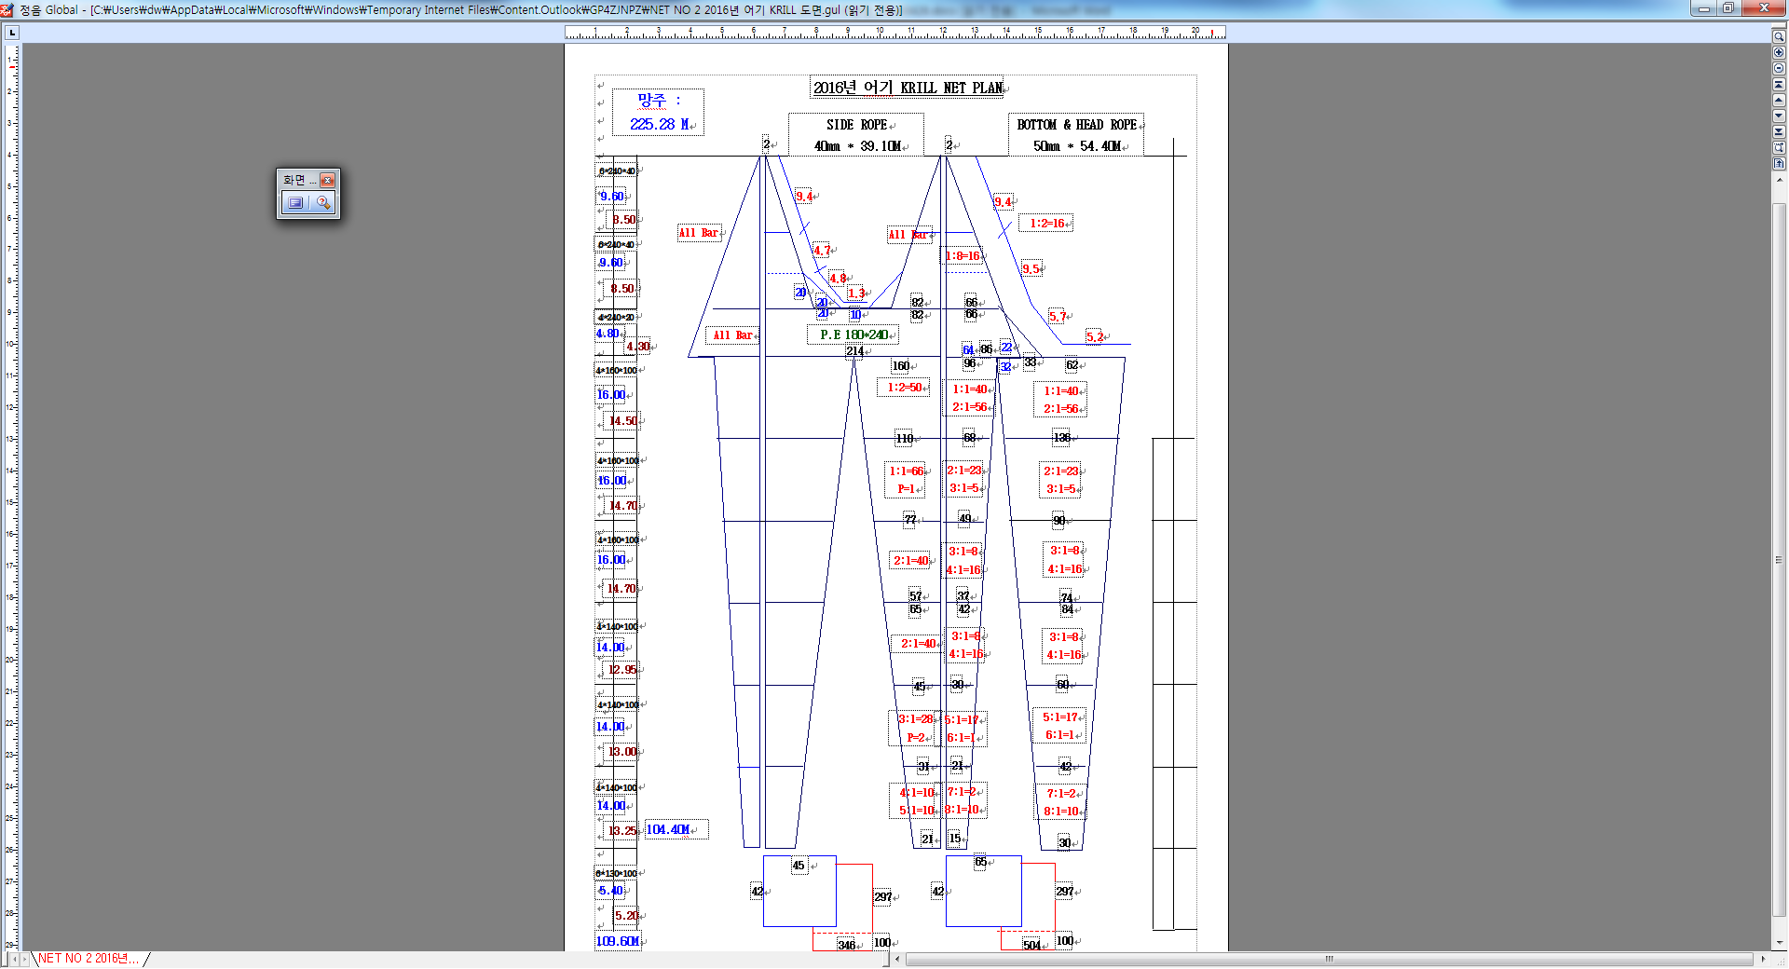



Net 1 & 2 Cod-end diagram(s) : SEJONG

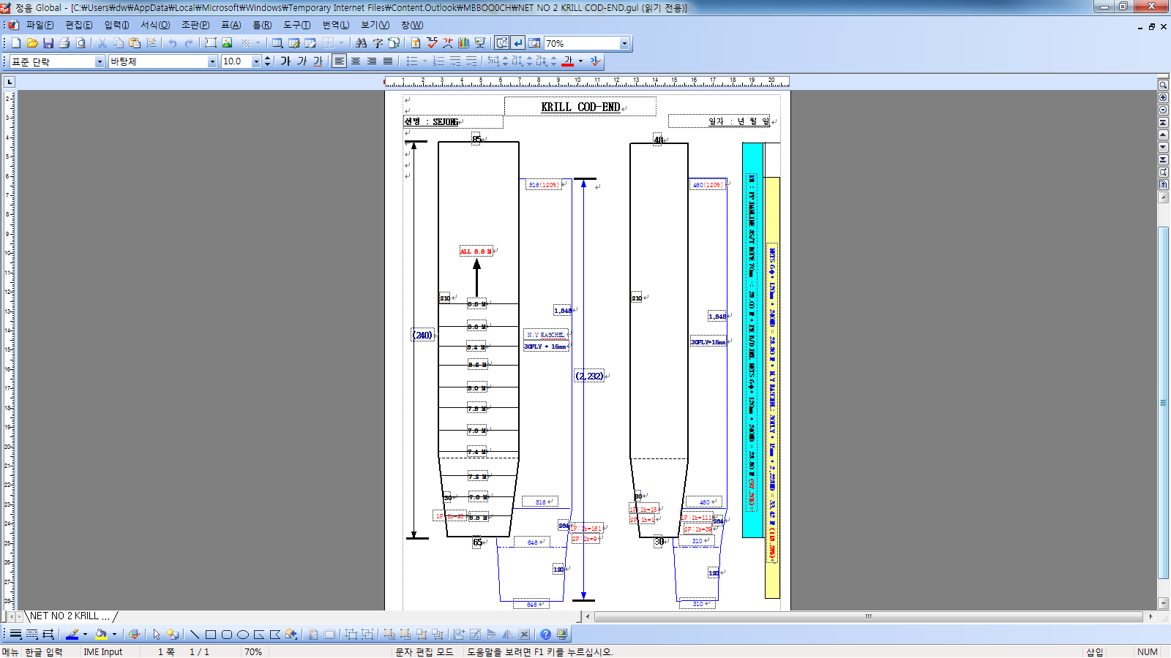

*For each net used, or any change in net configuration, refer to the relevant net diagram in the CCAMLR fishing*

*gear library if available (www.ccamlr.org/node/74407), or submit a detailed diagram and description to the*

*forthcoming meeting of WG-EMM. Net diagrams must include:*

*1. Length and width of each trawl panel (in sufficient detail to allow calculation of the angle of each panel*

*with respect to water flow.)*

*2. Mesh size (inside measurement of stretched mesh based on the procedure in Conservation Measure 22-01),*

*shape (e.g. diamond shape) and material (e.g. polypropylene).*

*3. Mesh construction (e.g. knotted, fused).*

*4. Details of streamers used inside the trawl (design, location on panels, indicate ‘nil’ if streamers are not*

*in use); streamers prevent krill fouling the mesh or escaping.*

Net 3 diagram(s): SEJONG

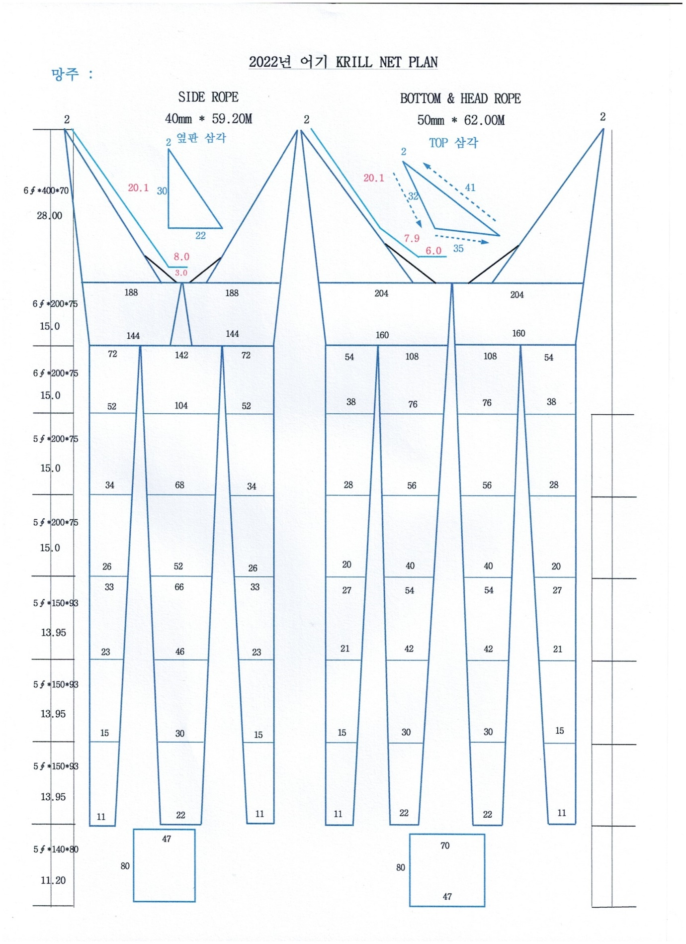

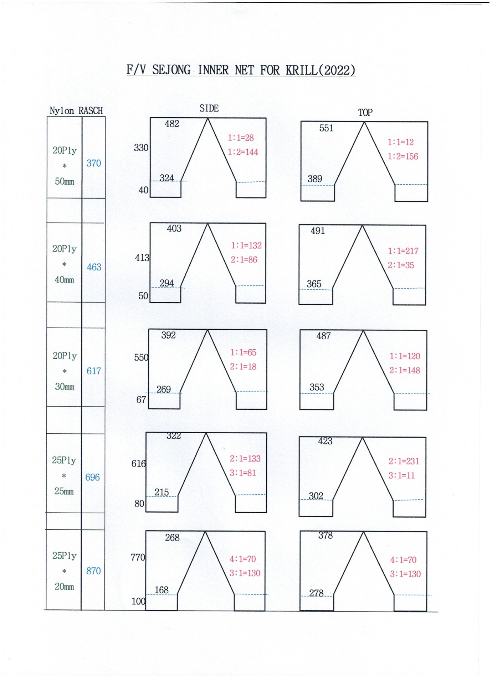

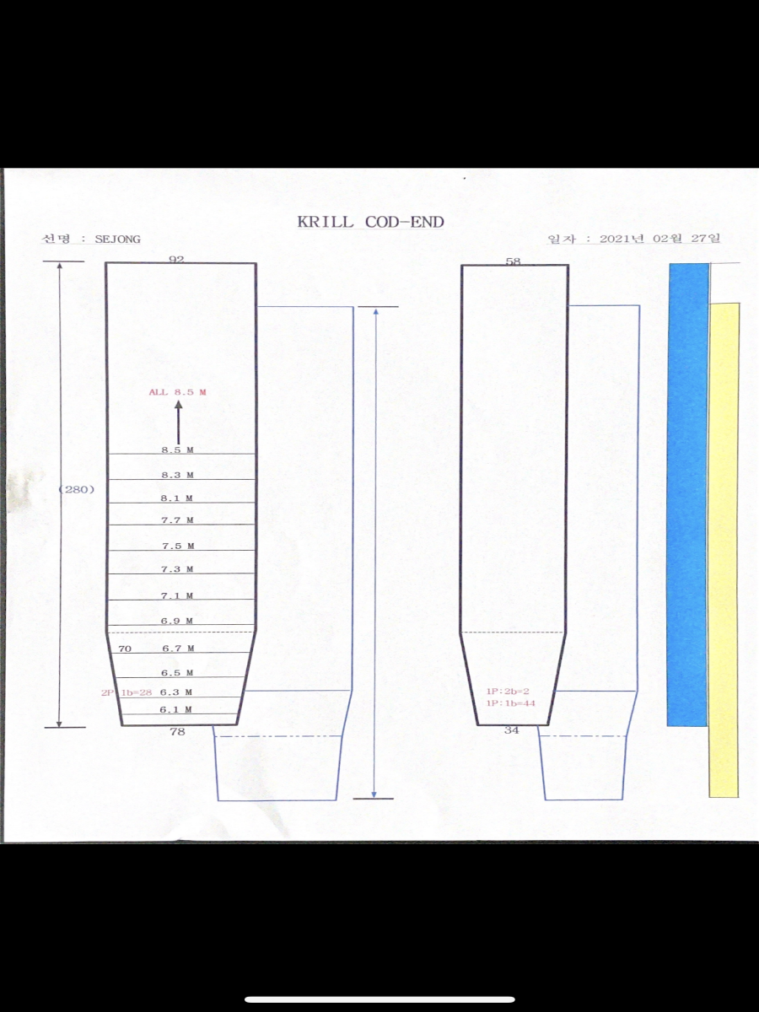

**Marine mammal exclusion device**

Device diagram(s): SEJONG

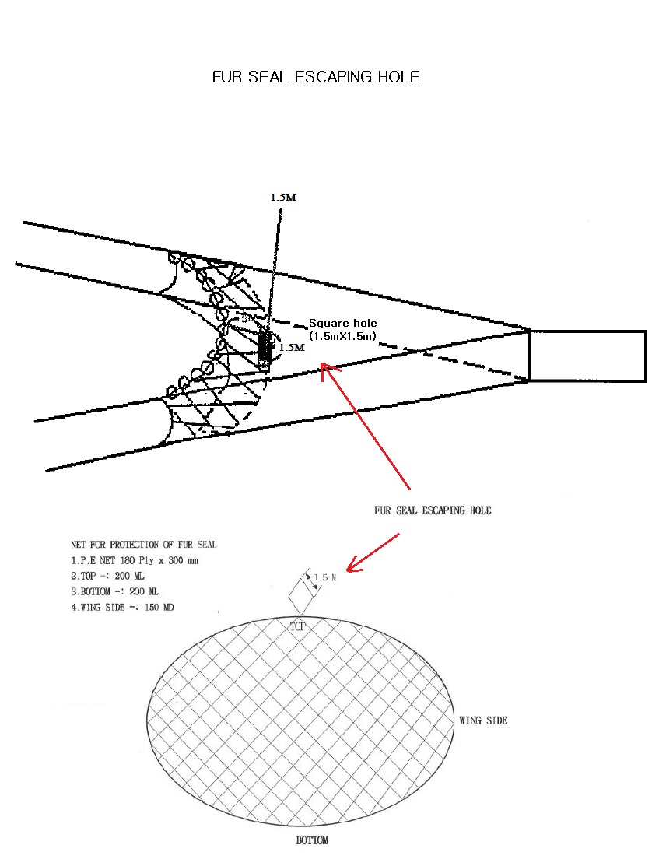

NET FOR PROTECTION OF FUR SEAL

1. P.E NET 180PLY X 300mm
2. TOP : 220 ML
3. BOTTOM : 220 ML
4. WING SIDE : 166 MD

*For each type of device used, or any change in device configuration, refer to the relevant diagram in the*

*CCAMLR fishing gear library if available (www.ccamlr.org/node/74407), or submit a detailed diagram and*

*description to the forthcoming meeting of WG-EMM.*

**Collection of acoustic data**

*Provide information on the echosounders and sonars used by the vessel.*

|  |  |
| --- | --- |
| Type (e.g. echosounder, sonar) | Echosounder |
| Manufacturer | Kongsberg Maritime AS |
| Model | SIMRAD EK80 |
| Transducer frequencies (kHz) | 38khz,70khz, 120khz |

Collection of acoustic data (detailed description): Collected acoustic data will be submitted to the NIFS(National Institute of Fisheries Science).

*Outline steps which will be taken to collect acoustic data to provide information on the distribution and*

*abundance of* Euphausia superba *and other pelagic species such as myctophiids and salps (SC-CAMLR-XXX,*

*paragraph 2.10).*