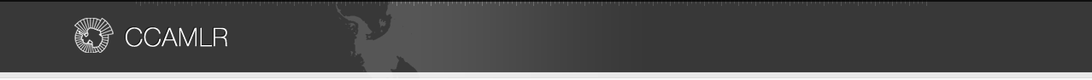
ANNEX 21-03/A

NOTIFICATION OF INTENT TO PARTICIPATE IN A FISHERY
FOR EUPHAUSIA SUPERBA

General information

Member: Republic of Korea
Fishing season: 2021/22 season
Name of vessel: SEJONG
Expected level of catch (tonnes of green weight): 20,000
Vessel’s daily processing capacity (tonnes of green weight) 240

Intended fishing subareas and divisions
This conservation measure applies to notifications of intentions to fish for krill in Subareas 48.1, 48.2, 48.3
and 48.4 and Divisions 58.4.1 and 58.4.2. Intentions to fish for krill in other subareas and divisions must be
notified under Conservation Measure 21-02.

Subarea/division | Tick the appropriate boxes
48.1 | V
48.2 | V
48.3 | V
48.4
58.4.1
58.4.2

Fishing technique : Tick the appropriate boxes
V Conventional trawl
□ Continuous fishing system
□ Pumping to clear codend
□ Other method: Please specify ___________________________

Product types and methods for direct estimation of green weight of krill caught

Product type | Method for direct estimation of green weight of krill caught,  where relevant (refer to Annex 21-03/B)1
Whole frozen | Holding tank volume
Boiled | Holding tank volume
Meal | Holding tank volume
Oil
Peeled | Holding tank volume
1 If the method is not listed in Annex 21-03/B, then please describe in detail ______________

Net measurements | Net 1 | Net 2 | Net 3
Net-mouth opening height (m) | 25.00 | 25.00 | 34
Net-mouth opening width (m) | 30.00 | 27.60 | 35
Total net length (m) including codend,  measured along the centreline of the net | 137.28 | 137.50 | 155.07
Codend-mouth opening height (m) | 2.88 | 2.88 | 2.88
Codend-mouth opening width (m) | 4.56 | 4.56 | 4.56
Codend length (m) | 28.00 | 28.00 | 28.00
Codend mesh size (mm: stretched mesh) | 120  (Inner 15) | 120  (Inner 15) | 100  (Inner 15)
Net configuration

Net 1 diagram(s): SEJONG
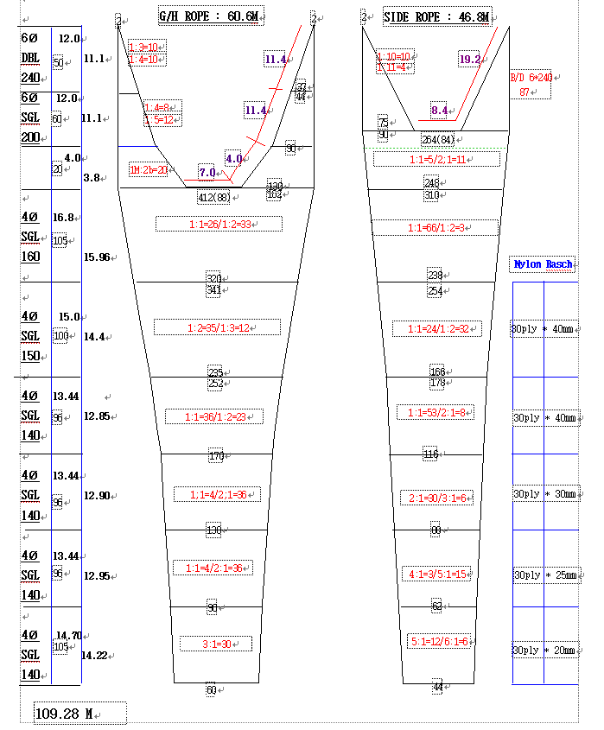
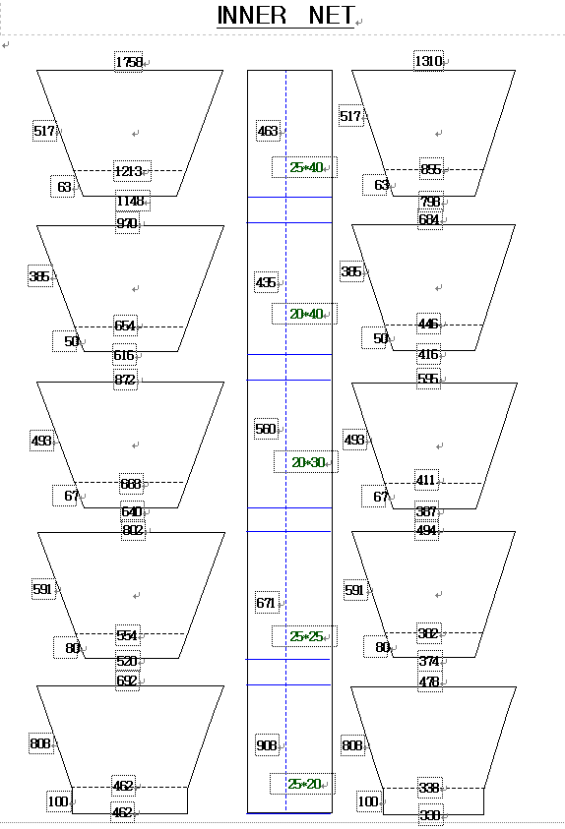

For each net used, or any change in net configuration, refer to the relevant net diagram in the CCAMLR fishing
gear library if available (www.ccamlr.org/node/74407), or submit a detailed diagram and description to the
forthcoming meeting of WG-EMM. Net diagrams must include:
1. Length and width of each trawl panel (in sufficient detail to allow calculation of the angle of each panel
with respect to water flow.)
2. Mesh size (inside measurement of stretched mesh based on the procedure in Conservation Measure 22-01),
shape (e.g. diamond shape) and material (e.g. polypropylene).
3. Mesh construction (e.g. knotted, fused).
4. Details of streamers used inside the trawl (design, location on panels, indicate ‘nil’ if streamers are not
in use); streamers prevent krill fouling the mesh or escaping.

Net 2 diagram(s): SEJONG
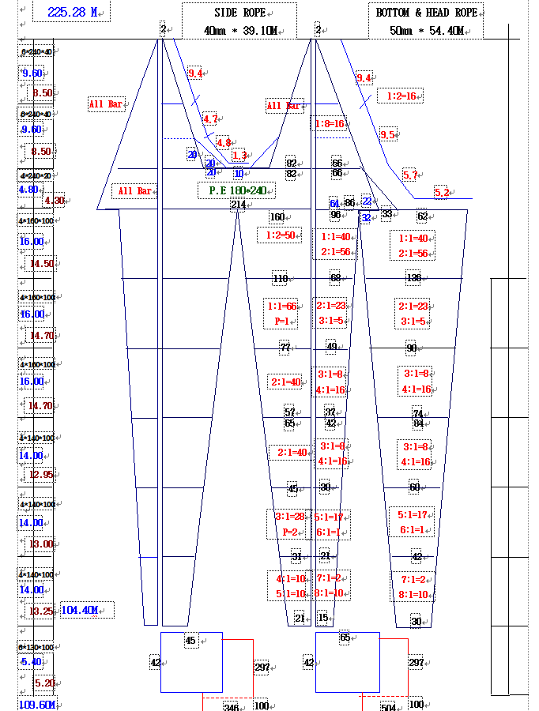

Net 1 & 2 Cod-end diagram(s) : SEJONG
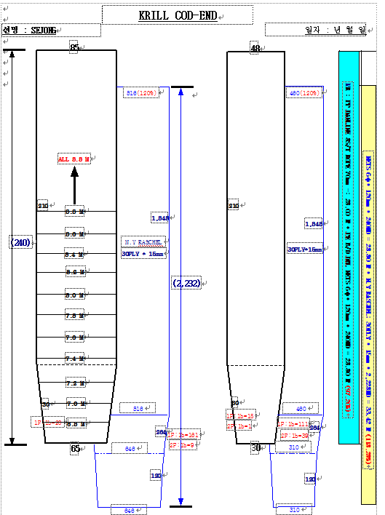

For each net used, or any change in net configuration, refer to the relevant net diagram in the CCAMLR fishing
gear library if available (www.ccamlr.org/node/74407), or submit a detailed diagram and description to the
forthcoming meeting of WG-EMM. Net diagrams must include:
1. Length and width of each trawl panel (in sufficient detail to allow calculation of the angle of each panel
with respect to water flow.)
2. Mesh size (inside measurement of stretched mesh based on the procedure in Conservation Measure 22-01),
shape (e.g. diamond shape) and material (e.g. polypropylene).
3. Mesh construction (e.g. knotted, fused).
4. Details of streamers used inside the trawl (design, location on panels, indicate ‘nil’ if streamers are not
in use); streamers prevent krill fouling the mesh or escaping.

Net 3 diagram(s): SEJONG
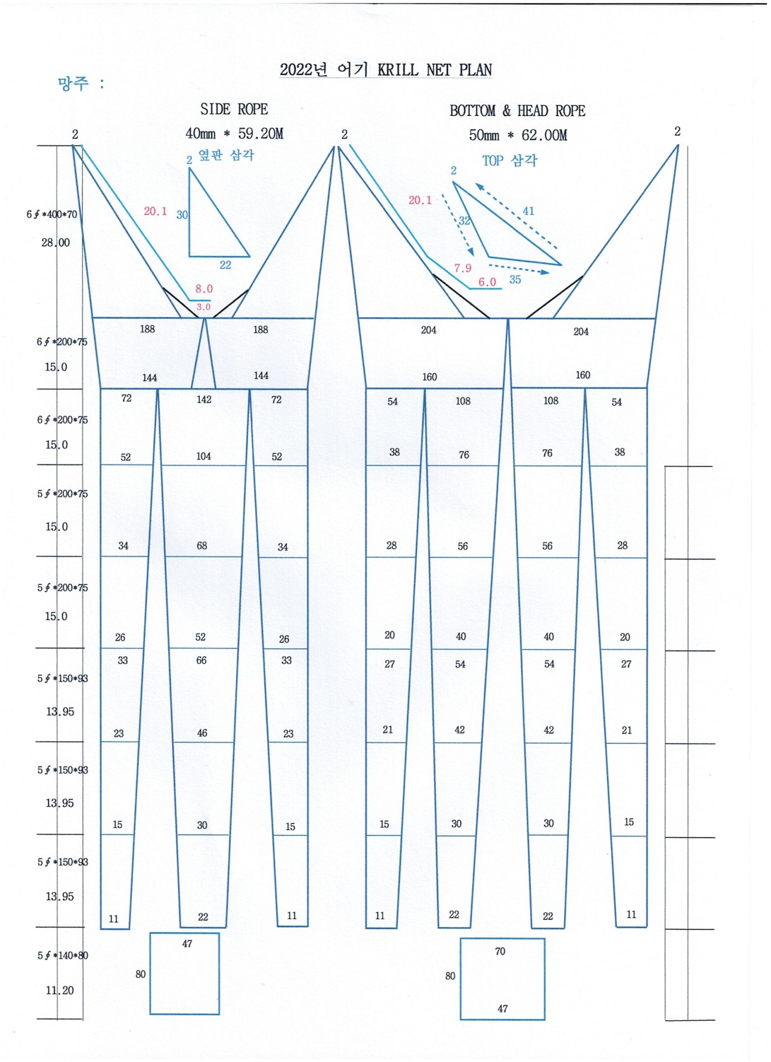

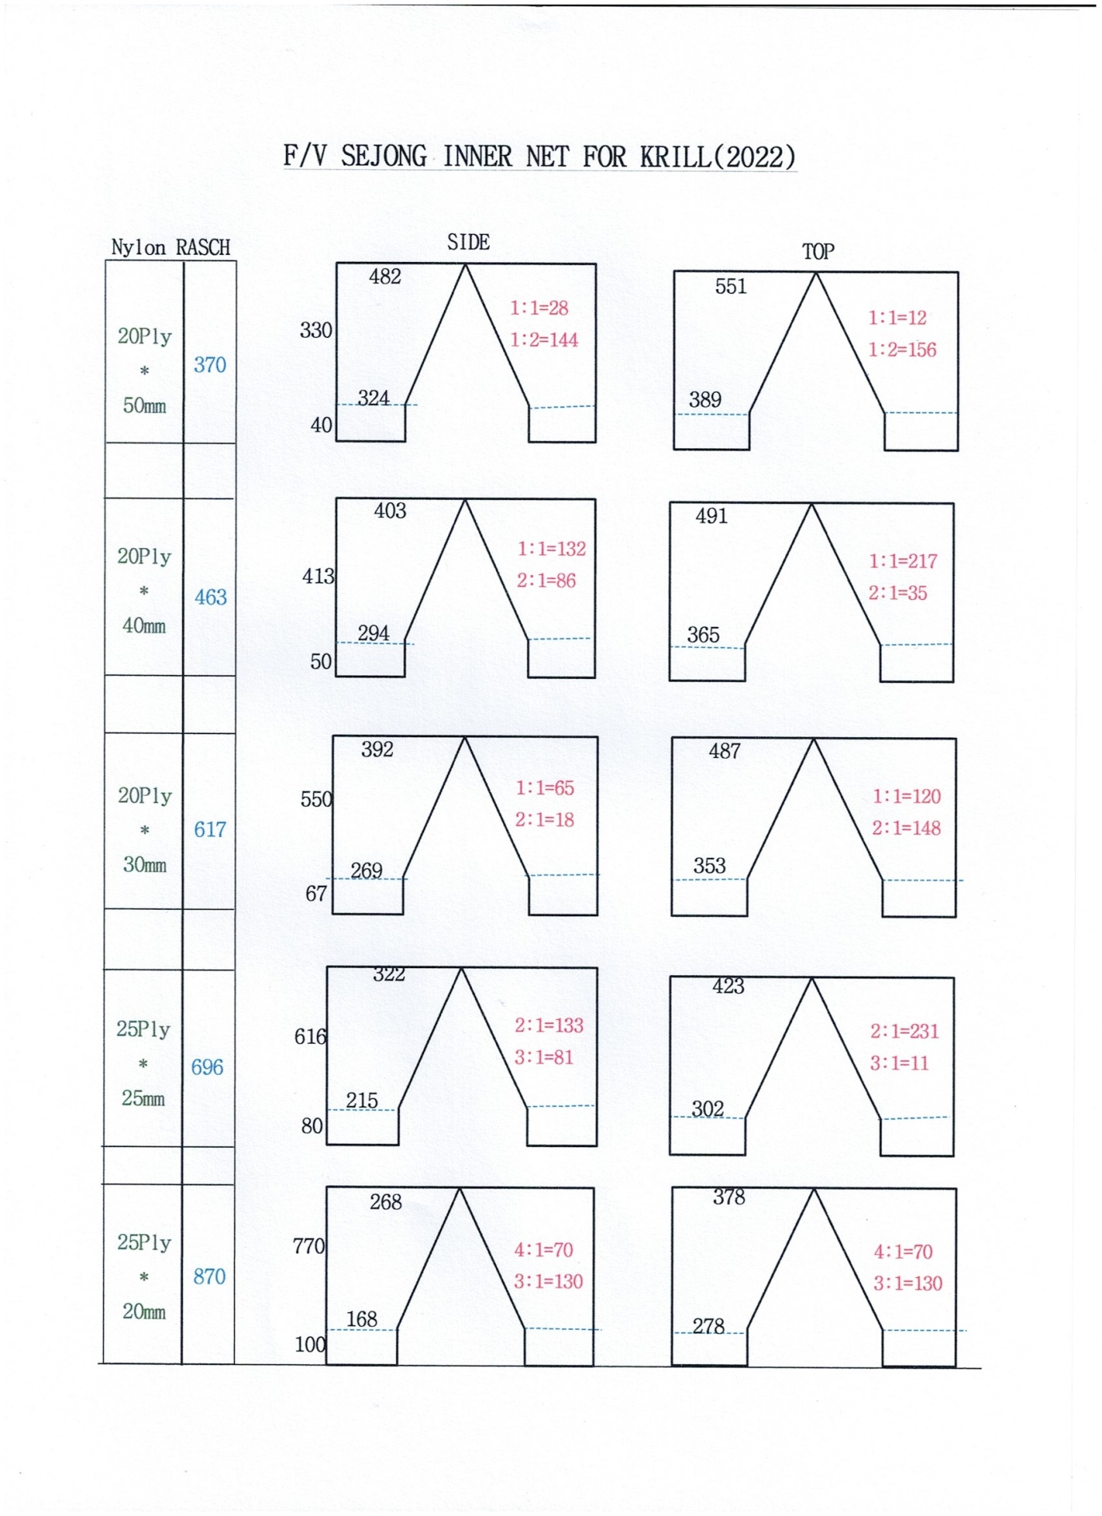

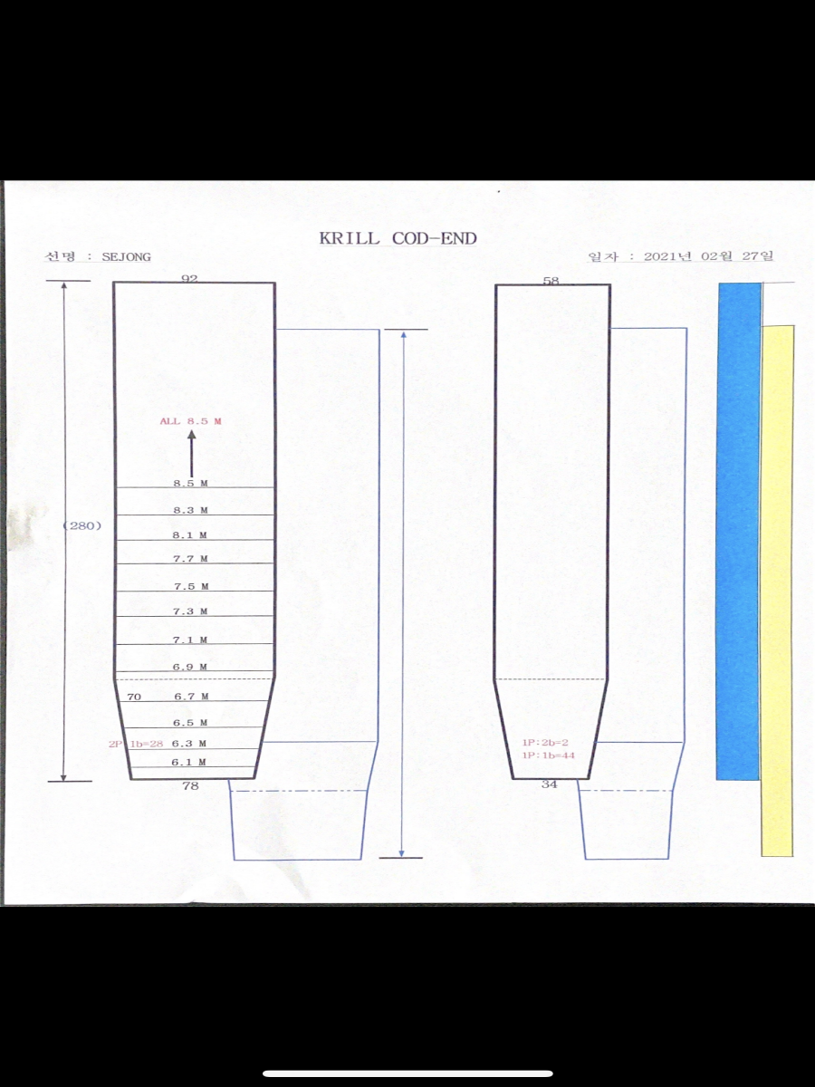

Marine mammal exclusion device
Device diagram(s): SEJONG
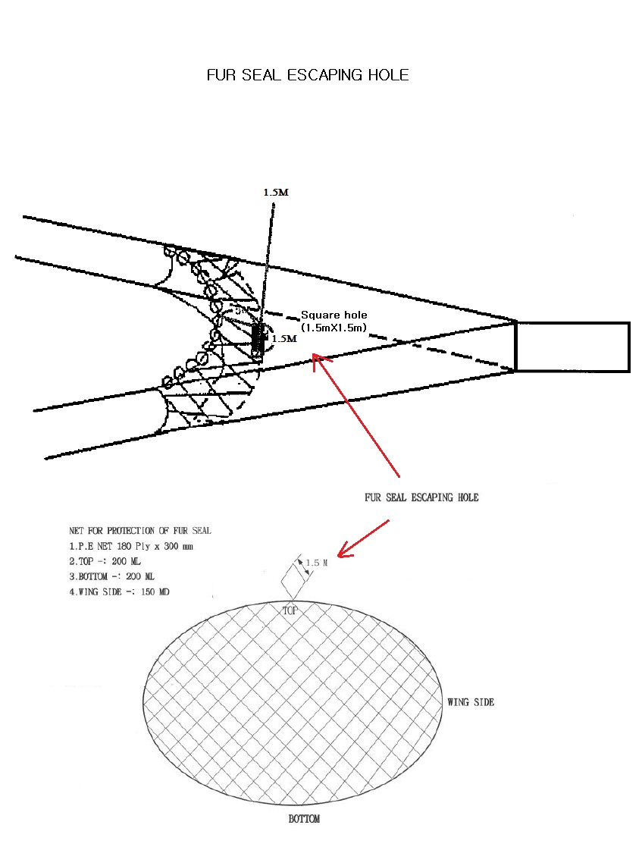
NET FOR PROTECTION OF FUR SEAL
- P.E NET 180PLY X 300mm
- TOP : 220 ML
- BOTTOM : 220 ML
- WING SIDE : 166 MD
For each type of device used, or any change in device configuration, refer to the relevant diagram in the
CCAMLR fishing gear library if available (www.ccamlr.org/node/74407), or submit a detailed diagram and
description to the forthcoming meeting of WG-EMM.

Collection of acoustic data
Provide information on the echosounders and sonars used by the vessel.

Type (e.g. echosounder, sonar) | Echosounder
Manufacturer | Kongsberg Maritime AS
Model | SIMRAD EK80
Transducer frequencies (kHz) | 38khz,70khz, 120khz

Collection of acoustic data (detailed description): Collected acoustic data will be submitted to the NIFS(National Institute of Fisheries Science).
Outline steps which will be taken to collect acoustic data to provide information on the distribution and
abundance of Euphausia superba and other pelagic species such as myctophiids and salps (SC-CAMLR-XXX,
paragraph 2.10).

