Net diagram(s): SAE IN LEDAER

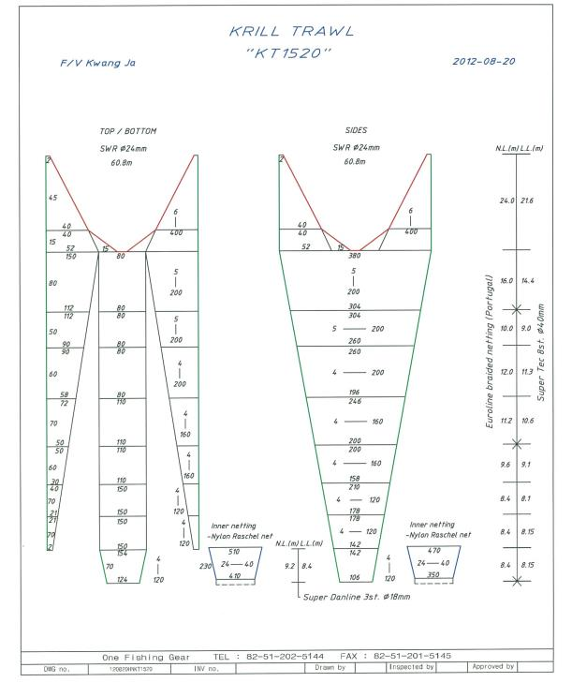

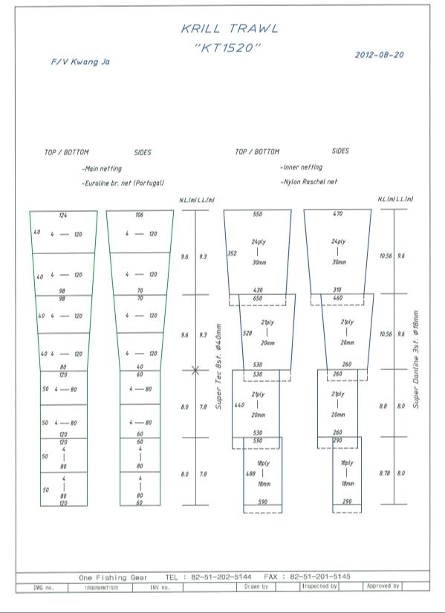

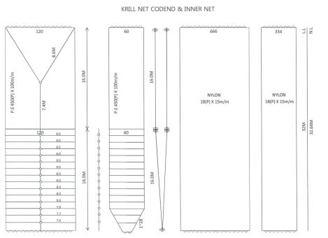

For each net used, or any change in net configuration, refer to the relevant net diagram in the CCAMLR fishing gear library if available (www.ccamlr.org/node/74407), or submit a detailed diagram and description to the forthcoming meeting of WG-EMM. Net diagrams must include:

- Length and width of each trawl panel (in sufficient detail to allow calculation of the angle of each panel with respect to water flow.)
- Mesh size (inside measurement of stretched mesh based on the procedure in Conservation Measure 22-01), shape (e.g. diamond shape) and material (e.g. polypropylene).
- Mesh construction (e.g. knotted, fused).
- Details of streamers used inside the trawl (design, location on panels, indicate ‘nil’ if streamers are not in use); streamers prevent krill fouling the mesh or escaping.

