**Net configuration**

Net 1 diagram(s): SEJONG

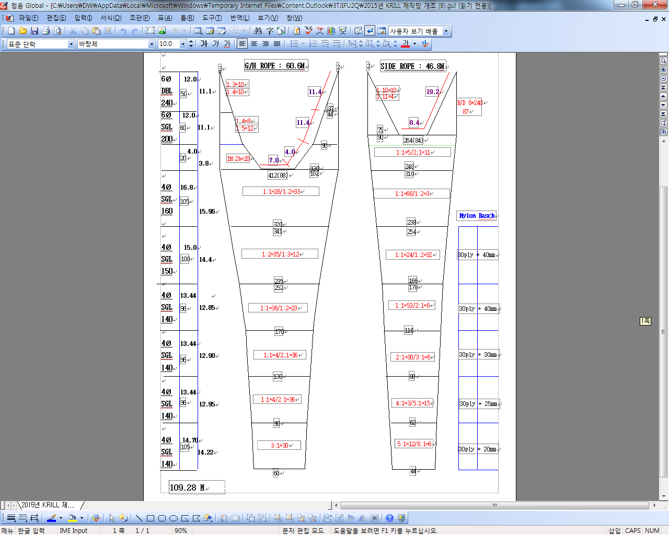

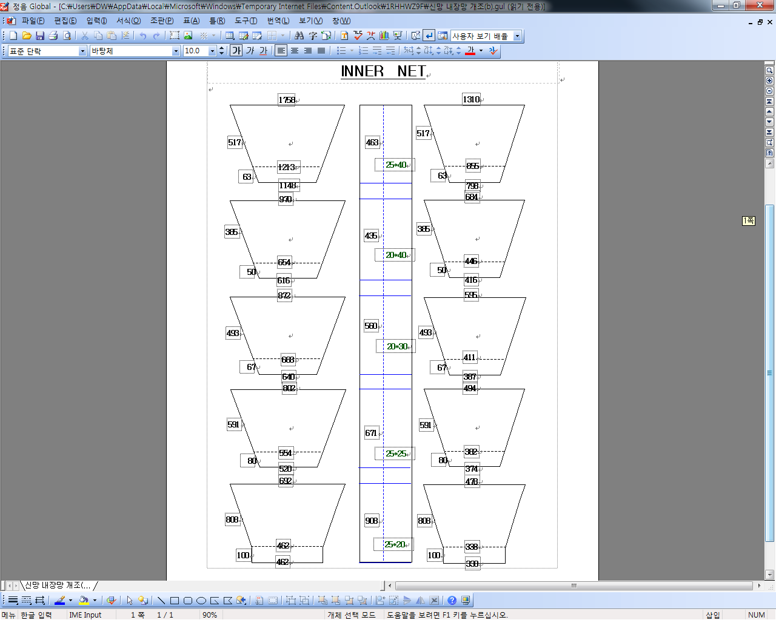

*For each net used, or any change in net configuration, refer to the relevant net diagram in the CCAMLR fishing*

*gear library if available (www.ccamlr.org/node/74407), or submit a detailed diagram and description to the*

*forthcoming meeting of WG-EMM. Net diagrams must include:*

*1. Length and width of each trawl panel (in sufficient detail to allow calculation of the angle of each panel*

*with respect to water flow.)*

*2. Mesh size (inside measurement of stretched mesh based on the procedure in Conservation Measure 22-01),*

*shape (e.g. diamond shape) and material (e.g. polypropylene).*

*3. Mesh construction (e.g. knotted, fused).*

*4. Details of streamers used inside the trawl (design, location on panels, indicate ‘nil’ if streamers are not*

*in use); streamers prevent krill fouling the mesh or escaping.*

Net 2 diagram(s): SEJONG

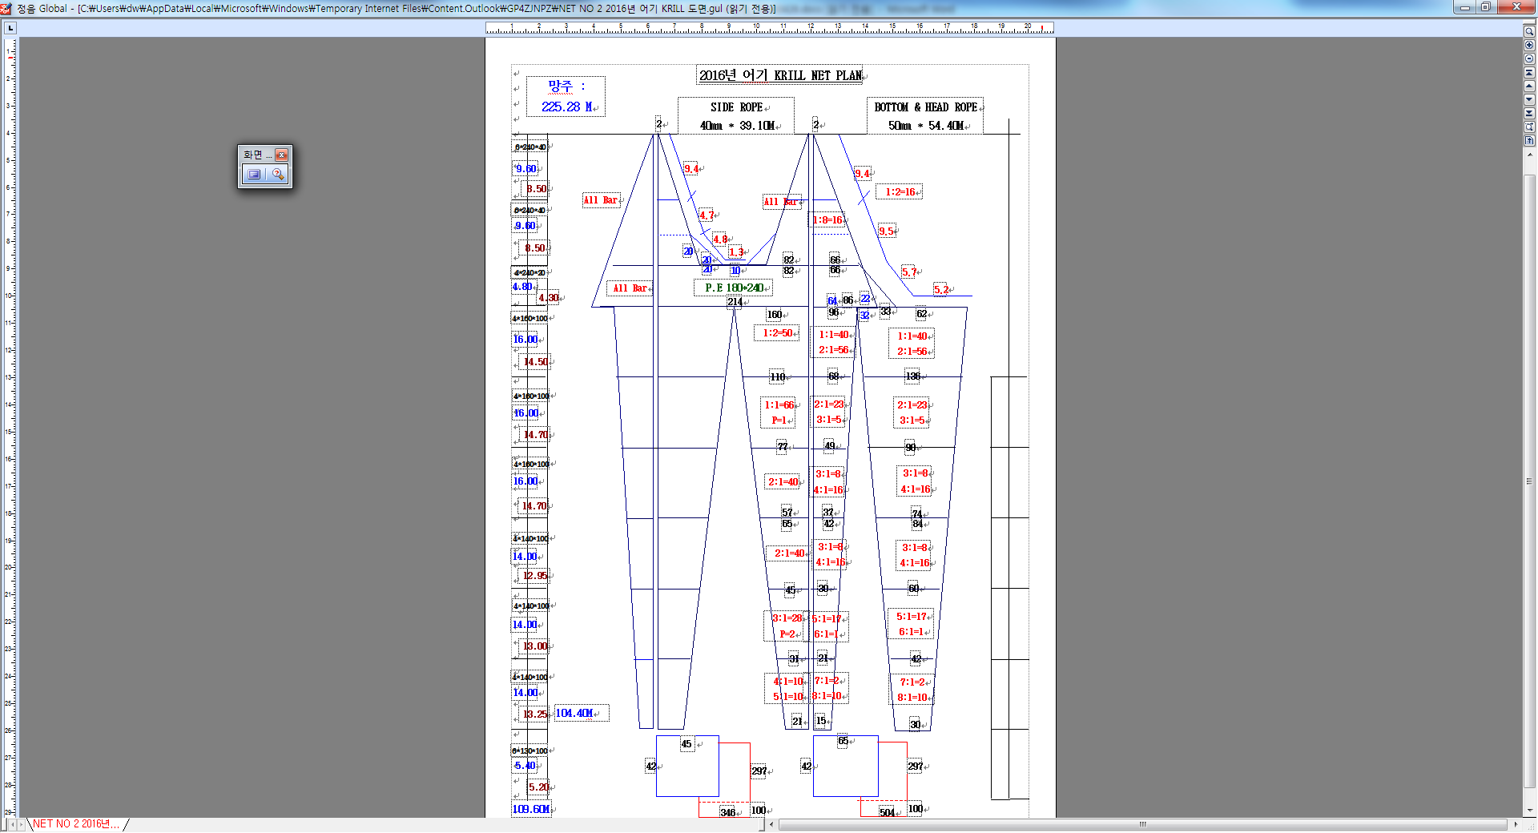



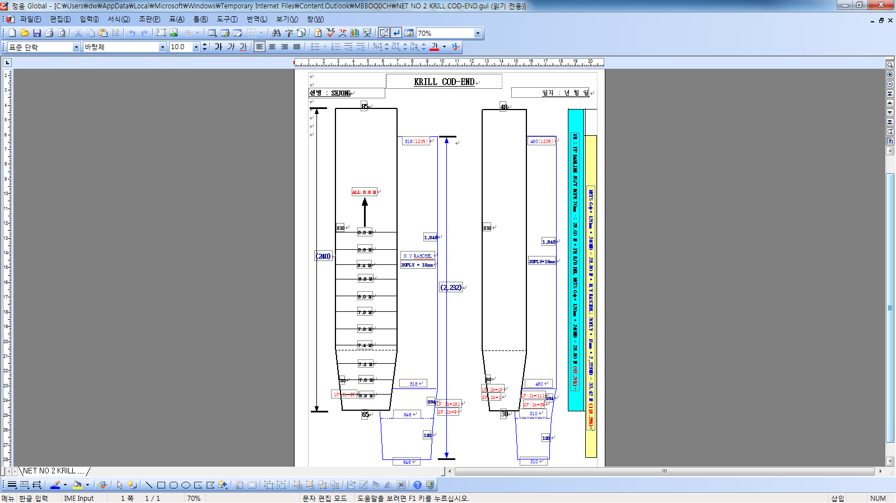

*For each net used, or any change in net configuration, refer to the relevant net diagram in the CCAMLR fishing*

*gear library if available (www.ccamlr.org/node/74407), or submit a detailed diagram and description to the*

*forthcoming meeting of WG-EMM. Net diagrams must include:*

*1. Length and width of each trawl panel (in sufficient detail to allow calculation of the angle of each panel*

*with respect to water flow.)*

*2. Mesh size (inside measurement of stretched mesh based on the procedure in Conservation Measure 22-01),*

*shape (e.g. diamond shape) and material (e.g. polypropylene).*

*3. Mesh construction (e.g. knotted, fused).*

*4. Details of streamers used inside the trawl (design, location on panels, indicate ‘nil’ if streamers are not*

*in use); streamers prevent krill fouling the mesh or escaping.*